Contents
1 Contents 1
2 Analysis 3
2.1 What is the problem? 3
2.2 Background information 3
2.3 Client and users 3
2.4 Research 4
2.4.1 Interview 4
2.4.2 Pygame research 8
2.4.3 Questionnaire 10
2.4.4 Game investigation 15
2.5 Requirements 16
2.6 Objectives 17
2.7 Modelling 19
3 Design 21
3.1 Database design and relationships 21
3.2 Stepwise Refinement 24
3.3 Menu interface design 26
3.3.1 Game intro 26
3.3.2 Main menu 26
3.3.3 Login / Signup 26
3.3.4 Customize 26
3.3.5 Leaderboard 27
3.3.6 Friend screen 27
3.3.7 Account screen 27
3.4 Navigation design 27
3.5 Class design 27
3.5.1 BUTTONS 27
3.6 Algorithm Design 29
3.6.1 Main menu 29
3.6.2 Play 29
3.6.3 Customize 29
3.6.4 Leaderboard 29
3.6.5 Log In 29
3.6.6 Log out 29
3.6.7 Sign up 29
3.6.8 Friends 29
4 Implementation 30
5 Testing 31
6 Evaluation 32
7 Bibliography 33

Analysis

What is the problem?
The problem which I am investigating consists of designing and developing an engaging 2D game for a client. This game will be developed and altered to meet my clients needs. This could include a local or global leaderboard with a reward system which encourages users to compete against one another, as well as a robust account system which allows users to save their progress and display their custom usernames onto the leaderboard.
All of these features will be easily accessible with a simple, aesthetically pleasing menu system which allows users to navigate the program efficiently. This could include signing in or creating an account, changing their password or usernames, customizing their avatar, or logging out. I want the function of this program to be self explanatory to omit any potential confusion from users who are less computer literate.

Background information
As most games are, this program’s purpose will be for enjoyment and entertainment.
A reward system involves giving a player an in-game advantage or a novelty item in exchange for the completion of a task or the achievement of being first on the leaderboard. The reward system will enable players to profit from time spent playing, which in turn prompts the user to spend more time playing.
A leaderboard is an in game feature which displays the top scores of all players who have played the game. Usually this will only display the top 10, but some programs have the option to display scores above and below the user in order for them to be educated on how many more points they need to beat the person above them. The leaderboard itself invites players from different devices and accounts to contend against each other in order to get the highest score possible.

Client and users

This program will be developed to meet the needs of a specific client, however will also take into account preferences of other potential end users of the game. For example, when conducting my research for the requirements for the program, I will ask for the opinions on many different individuals aged 16-18 for what they look for when choosing a game to play. However, I must take into account that it is not only this age group that enjoy games, therefore will conduct more research into features of games which make people are inclined to play them.
My main client is a student at a sixth form, who expresses an interest in simple, low effort games which she can play without an internet connection. Our initial conversation where I proposed the idea of developing a game to her was brief, however she introduced the idea of a game revolving around cats, with the potential to customize her own avatar. Additionally, she expressed a preference for games which did not have a heavy competitive nature. For example, she mentioned disliking games such as CS:GO due to the high pressure to perform as a teammate against the opposition. This sparked the idea of more of a easy-going, low effort game which can still be enjoyed without any stress.

Research
The ways I intend to collect data to aid my development of this project is to interview my client, research modules and features of Pygame as well as experiment with different features, conduct a questionnaire to gather preferences of other prospective end-users, and also investigate existing games with similar features to my own.
I aim, for the interview, to collect data regarding the actual gameplay of the program as well as the aesthetics. This is because I believe the client herself will be able to give me the best idea of what she wants for the game. For the Pygame research, I want to learn the basics of initiating a game window, as well as simple movement. Additionally, I want to learn the basics of creating and using a hash table in python.
For my questionnaire, I want to know the general likes and dislikes (regarding gameplay) of other potential end users. Finally, my aim for the general game research is to find games similar to my own, whether it be design or gameplay, and potentially incorporate different features of these games that I feel are appropriate into my own.

Interview

For my interview, I wanted to make my questions less broad than my questionnaire, and instead focus in on different aspects of the game. This includes aspects like the customization of the character, the account system, alongside details of the game mechanisms itself. Prior to the interview, I will write down a few features or ideas to mention, however I believe letting the interview be more of a free environment would be more beneficial as my client may be more inclined to introduce her own ideas instead of just answering my own questions. This helps provide me with information I may have overlooked which could’ve proved to cause complications later down the line. Additionally, encouraging my client to bring her own opinions to the interview allows the end product to be more tailored to her own requirements.
I think splitting the interview into different sections will result in the analysis being more structured and easier to learn from. My first section will ask my client about her own personal likes and dislikes when it comes to games she’s played in the past, and also any additional general background information. My second section will be based on the function of the actual game and what features my client wants it to incorporate. My third section will revolve around the design of the game; this includes the art style of the backgrounds and sprites as well as information on the customization feature of the user’s avatar. I will include a transcript of this interview below, alongside an analysis to her answers:
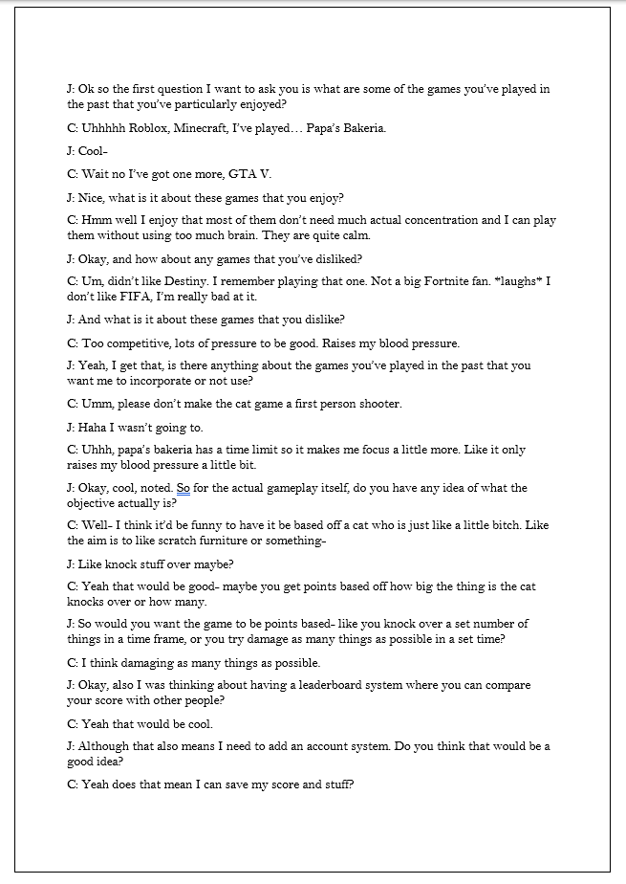|
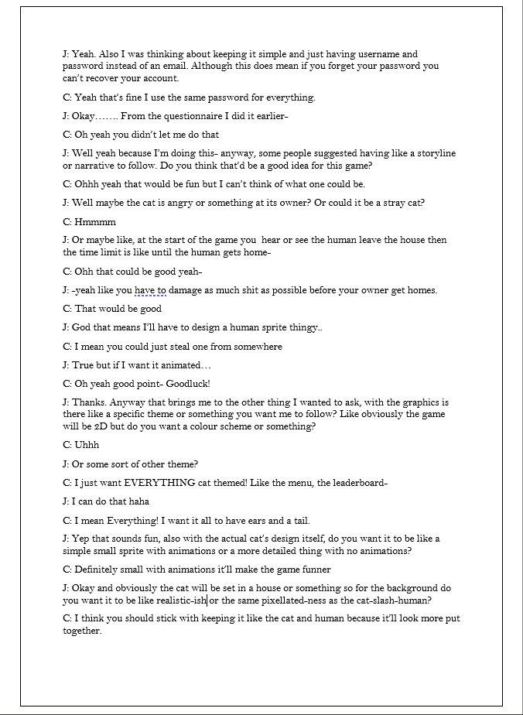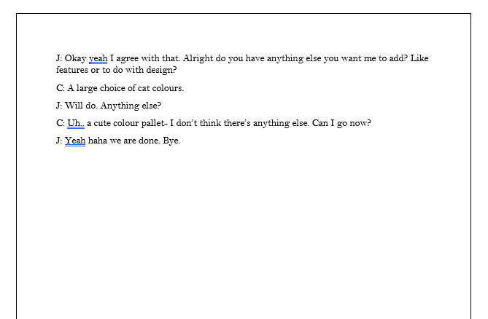
From section one, (orange) I can clearly see that my client wants a more relaxing, laid back game which doesn't require high skill. She mentions disliking games which are "Too competitive", which suggests that despite not enjoying excessive rivalry, there is still potential for some to be added. This will help me with my game design, as it shows me that developing a "calm" game is more likely to fit my clients requirements.
From section two (green), I ask interview my client about what she wants the actual gameplay to be. She initially mentions incorporating a time limit, as this is something she enjoyed in "Papa's Bakeria" due to it making her "focus a little more" as opposed to getting distracted and finding it difficult to pay attention as she plays. As well as this, we develop the idea of the game being based on a cat who is left home alone, and as a result begins to cause chaos. The game will therefore be set in a home, with the objective being to destroy as many objects in the house as possible before the time limit ends / human gets home.
Furthermore, I propose my idea of including a leaderboard system. My client responds well to this, and this conversation expands to the idea of needing an account system.

In section three (purple) we begin to discuss the graphics of the game. I ask my client if there is a particular theme she wants me to follow when designing a game. She responds with requesting a cat theme. Although the game itself will be based on a cat, she explains that she wants the menu and leaderboard to also be cat themed. I assume this extends to the account menu system as well, thus will have to spend some time designing a custom interface to meet my clients requirements. Furthermore, my client tells me she wants the cat (and most likely other movable aspects of the game) to have an animation aswell as having a large array of colour options to choose from so she can customize her cat. This will be another

Pygame research
In order to know the capabilities and limitations of my chosen coding language, I decided I needed to familiarise myself with Pygame. The goal of this research is to explore the different syntax and integral modules in Pygame. This includes creation and movement of characters, implementing gravity, and ways to animate the sprites. This allows me to move through the development stage more fluidly, reducing any issues where I’m unable to progress simply due to unawareness of built in functions. Additionally, knowledge of these different functions could help me plan and design how I can best suit the client’s requirements, alongside predicting any possible challenges or limitations I may face.
I first installed Pygame and used a YouTube tutorial to learn the very basics. [1] This included any required imports of images or libraries, the while loop needed to close the program, creating the main program loop, and also initiating the view window. As I watched this tutorial, I copied the code down into my own file so I could run it myself. After the code was written, I went back through it and used many comments to illustrate to myself what was happening at each line. This helped me deepen my understanding and know why each line was necessary for the program to run, and how a feature could be used in a different script.

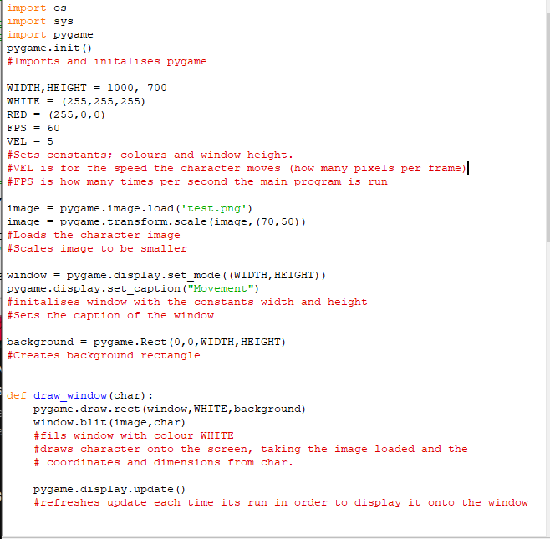
After all the essential features were set in place, I decided to learn how I could create a character and make it move. Later I would learn that using object operated program and utilising classes is ideal for sprites/characters, as it easily allows you to create multiple and also build in functions for animation or interactions. I learnt the basic movement code through another video, [2] and I did a similar annotation process to the previous tutorial.
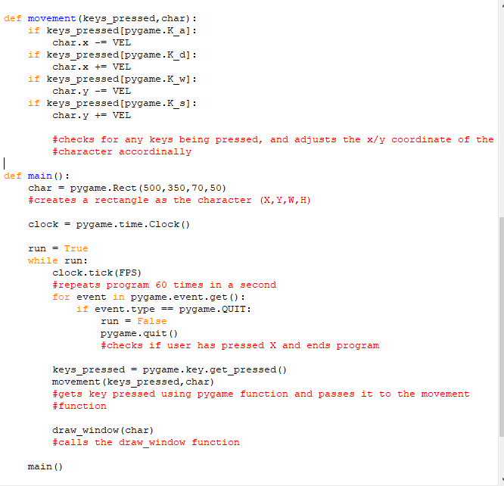

At this point I was encountering many syntax issues despite following a tutorial, however I eventually got a basic program to work and experimented with the features like velocity speed.
Another Pygame experiment I tested was the addition of gravity into a game. This would involve initialising the character and ground level, as well as allowing the user to make the character jump.
I felt this was necessary, as with the type of game that the client wants, the character being able to move fluidly and without bugs is important to maintain the program’s quality.
I decided to solve this problem without the initial use of a tutorial, instead relying on the skills I had learnt from the previous solutions. This took some time, as I learnt that to make the movement of the character jumping then falling, non-linear increments would be necessary. I did this through creating a jumpCount variable, which increased and decreased between -15 and 15, and performing a calculation on it. This was ideal as it meant, when jumpCount = 0, there was a slight pause at the top of the jump before the character began to fall.
After I got the program to work, I continued to experiment with different variables like the value of jumpCount, or the amount I increased char.y by each frame. This showed me what I could change to make the character jump higher or fall slower.

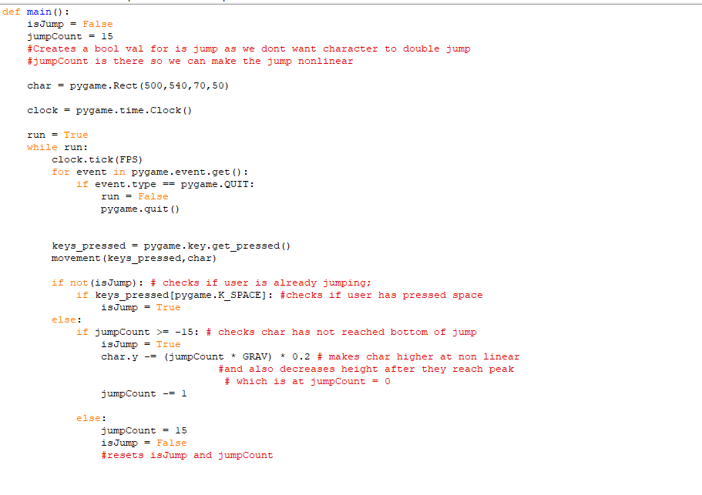
Questionnaire
As I had already conducted my interview with my client, I want to focus my questionnaire on the general likes and dislikes of other potential end-users. Basing the questions on the individuals likes and dislikes surrounding games will provide insight as I start my design process. I feel this was an appropriate data collection method, as interviewing many individuals personally would be time consuming and difficult to arrange due to people’s availability. Therefore, a questionnaire can get high quantities of answers which I can analyse. Furthermore, through using google forms, I can compare all answers to a single question, which can clearly show me if there’s a trend in the types of games or features of games that individuals like.
I decide to make the questionnaire anonymous, as I don’t see a need to collect the identity of the people who answer. This meant that they can answer more honestly and did not feel any pressure to write certain things.
Question 1: My first question was asking the user’s age. I feel this was appropriate as knowing the age of the different peoples answers could help me make a judgement for what features would suit my target audience’s preferences best. For example, if all the 16-18 year olds said they didn’t like singleplayer games, then I could try aim to make my game multiplayer.
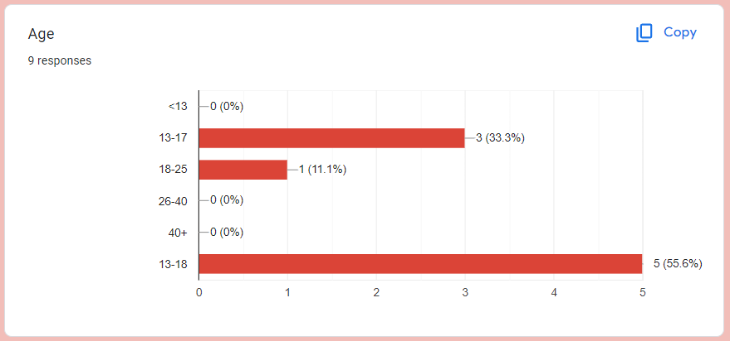
Analysis: My questionnaire was mainly sent to those who fit into my target age range, so these results were expected. In retrospect, it probably would’ve been more efficient to get a larger quantity of answers from every age range, so I could then analyse the different age group’s answers and see if there was a significant difference.
Question 2: This question asks how regularly the user plays games. Although this question feels less necessary, I decided to incorporate it as I considered the idea that people who play games rarely may have less of an educated view than those who play regularly. This is because they will have had a wider and deeper experience and may be more in tune with their preferences than someone who plays games rarely. However, this doesn’t mean I will discount the questionnaire results of those who barely play, but I do have to take this into consideration.
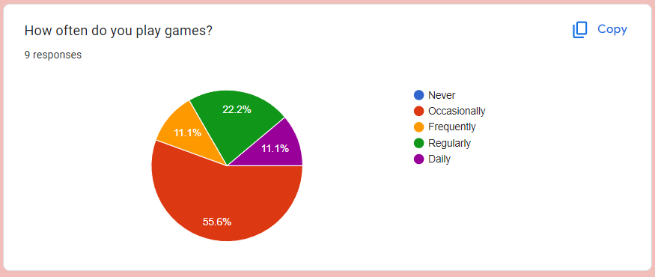
Analysis: From these results, I can see that the majority of those who took the questionnaire only occasionally play games. This is useful information, as it shows me that those who play my game may not take it very seriously, meaning that incorporating competitiveness is less important than other features. Additionally, this information indicates to me that it may be better if I use usernames instead of emails for the account system. This is because, as my users won’t be playing the game regularly, they may not want to connect personal information to the game. This means, if I used an email-password system, users may be deterred from making an account, therefore are less likely to play the game.

Question 3&4: My third question was asking the user what games they had played in the past and enjoy. I feel this was an important question, as knowing which games my target audience like can help fuel my future investigation surrounding games which were similar to my end user’s preferences and my client’s requirements.
The fourth question is asking what in particular they like in these games. I feel this would help me analyse the overall results of the questionnaire, as going off just a game they put may prove challenging, as they could like a variety of unique features which may not cross my mind unless I ask for their input. This would be time consuming to execute, which is why I feel this question is important.
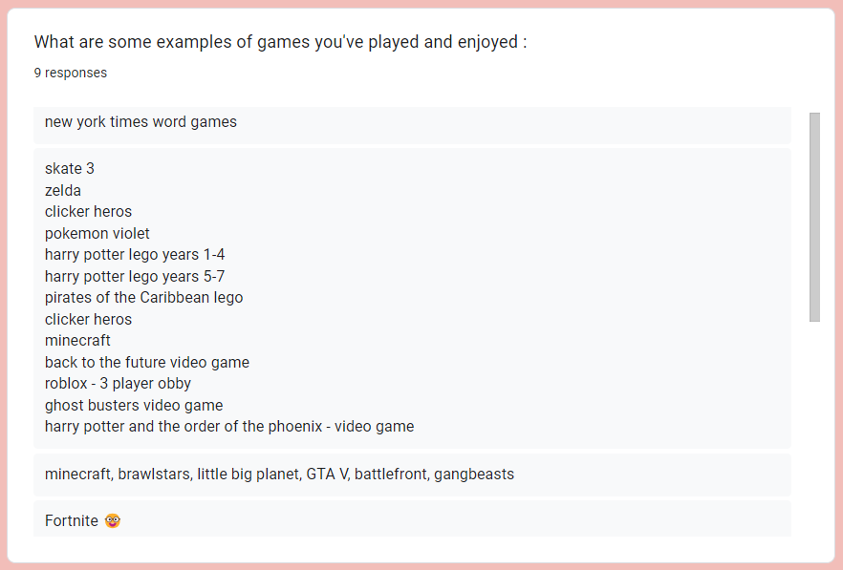

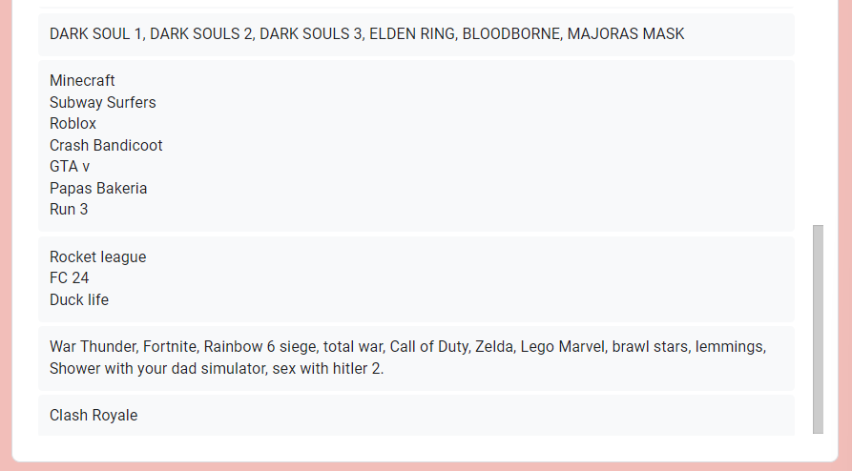

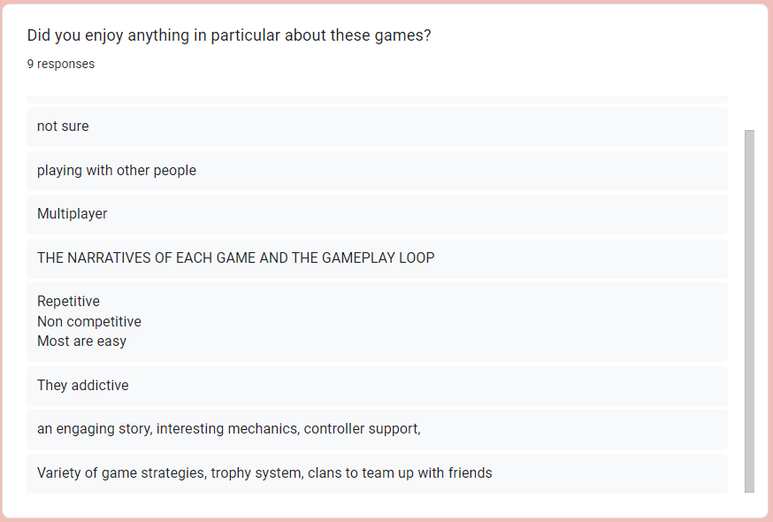

Analysis: For these, I decided to focus on question 4, as many games mentioned on the 3rd question aren’t incredibly relevant to the type of game that I am looking to develop. However, knowing the aspects of each game that are enjoyed allows me to research further into a specific game if necessary.
From these results, generally my target audience enjoys a multiplayer game, however not directly competing against someone. I know this from the ‘Multiplayer’ and ‘Playing with other people’ in combination with the ‘non competitive’ and ‘cleans to team up with friends’. In addition, a clear and entertaining story/narrative is enjoyed, which gives me a new feature to think about as I develop the game. Adding a storyline to my game could provide additional structure to the actual gameplay, as well as creating a more engaging and immersive experience.
Question 5&6: My fifth question consists of asking the user if they have any games they dislike, and my sixth asks them to expand and write if there is anything in particular which they dislike. I feel this would help me massively, as it prevents me spending time and energy designing and developing code which wouldn’t be used in the final result, due to it being an unpopular feature and make people enjoy the program less enjoyable.
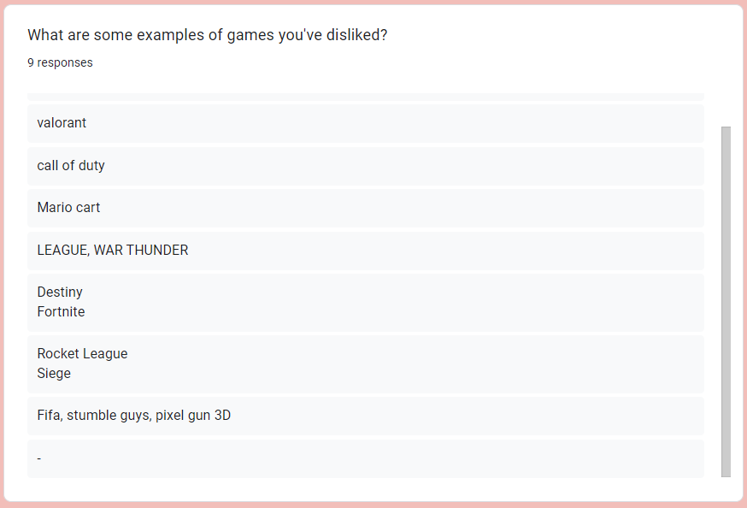

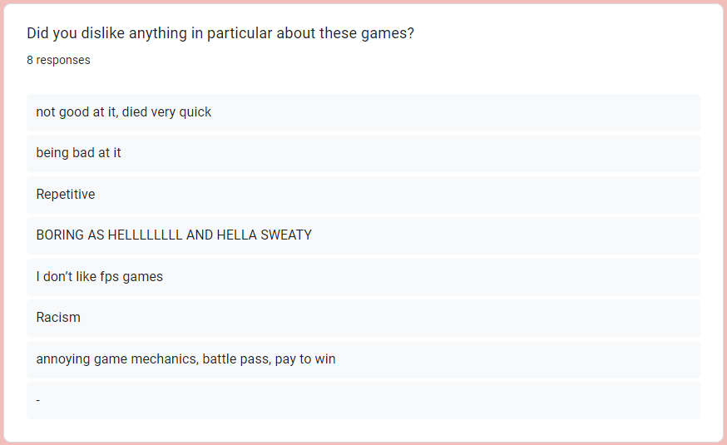

Analysis: For these results, the majority of responses involve disliking games that are too difficult, (“being bad at it”, “not good at it”, “annoying game mechanics”). This suggests that my game shouldn’t be too complicated, with simple controls which are easy to learn. This aligns with my original view of wanting the game to be easy for anyone to be able to play.
Question 7: My final question examines what type of game my users like to play; single-player, multiplayer; where you work as a team, or multiplayer; where you work against one another. I believe I can utilise this information when creating a leaderboard system, whether I encourage competitiveness or simply allow users to see their own high score but no one else’s.
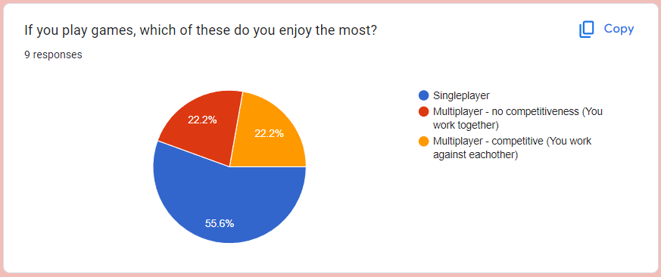
Analysis: The results of this question shows me that the majority of individuals prefer singleplayer games, however an aspect of multiplayer is also enjoyed. I think this allows me to incorporate my original ideas of having the actual gameplay itself be single-player to reduce the pressure to perform, however also bring an optional competitive nature with the leaderboard system.

Game investigation
For my game investigation, I decided to pick three games to research in order to get more information on how I will design and develop my own program. I want the first game to be the choice of my client. This could be either a game she wants the game to similar to, or a game which she has enjoyed in the past. I asked her in our interview and she decided on: “Papa’s Bakeria”. The second type of game I want to research is a game with similar graphics to my game. This would preferably be a game involving 2D cats. The third and final game I want to research is a game where the actual gameplay itself is similar. I had to choose this game after the initial interview with my client where she and I further developed a structure for the gameplay, and I decided on “Untitled Goose Game”

Papa’s Bakeria
In this game, you work as an employee at a fast food chain and have to complete orders quickly and correctly in order to make the customer happy. You’re rated on different factors, including the quality of the food and how long it took for it to be made.
As I played the game I took notes on aspects of the game I enjoyed personally and how I could translate that into my own game. This includes the consistent, cartoon-ish design of the game. Both the background and the character itself had the same colourful, enjoyable art style, as well as the menu itself being in this same style.
Secondly, the game has no visible timer counting down the time until the food is burnt or the customer is unhappy, which does bring an increased enjoyment to the game as you have to manage your time and keep checking on the food. However, I’m unsure if this is a feature ill be able to add into the game. I might be able to code a moving clock somewhere in the background of the game, however I don’t know if this will make a difference in terms of enjoyment compared to just having a digital timer in one of the corners. I could potentially incorporate both, as the clock feature may just be a fun novelty.
Thirdly, after you complete the order, you get a rating and money depending on how well you’ve completed this order. While playing, this gave me the idea of if you can reach a certain amount of points in my own game, you unlock certain cat colours. For example, you start with a plain white cat, but if you reach 10 points within the time, you can choose between a white cat or a black cat. This can then continue for however many cat colours until the final colour, which is only unlockable if you reach the #1 Leaderboard spot.
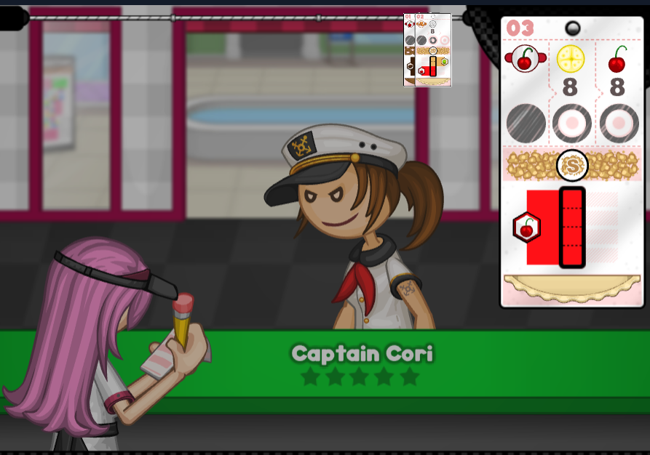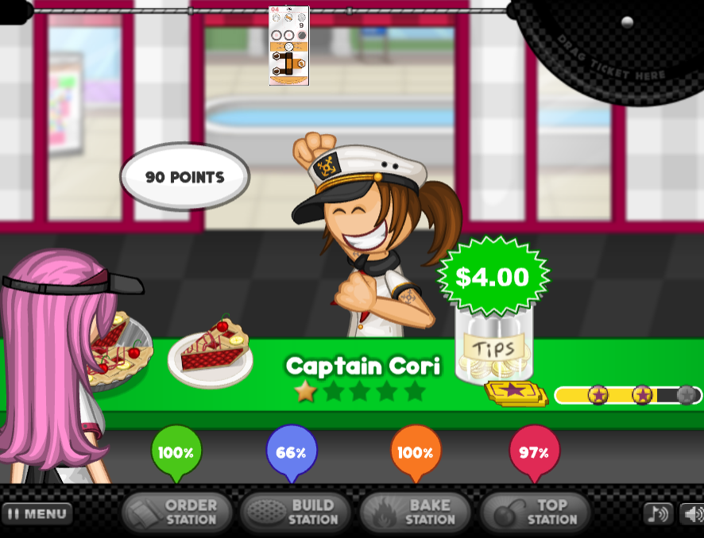
Untitled Goose Game
In this game, you play as a wild goose who wreaks havoc onto a town. There is a variety of different levels, and you have to complete most objectives in a level in order to proceed to the next. This game is very fluid and has no loading menu between the levels. Instead, for example with one of the levels, after you complete the necessary objectives, a door unlocks which you can walk through to the next level. This means you can go back on yourself if you want to go back to a previous level. Furthermore, this game has a free-play element where if you want, you can just walk around stealing objects from people and annoying them.
I think this is a perfect game to research gameplay wise, as my game will focus on a cat causing chaos in a house, and this game is about a goose causing chaos in the streets. This means that while playing, I can take note of any particular features that make me enjoy the game.
One small feature which inspired me is the ability to honk. Although this is a small feature, its incredibly fun to use. Therefore, I think incorporating a button which allows the cat to meow in this game would be enjoyable, and I think my client and any other potential end users would enjoy.
Another feature I enjoy is that pretty much every object in this game is interactable even if you don’t use it for any missions. This adds a bit of creativity and freedom in the game, where you can cause your own chaos and not have to abide to the game’s set objectives. I think I could add something like this into my game, where although there are objects which your aim is to break/knock over, I could also add other objects like a TV or sofa which you can scratch. This could give you extra points or could just stay as a fun feature.
Cat goes fishing
I decided to pick this game because, like mine, it is based around cats. Additionally, this game is also 2D.
In particular, I enjoyed the simplicity of the backgrounds of each scene. They had clearly drawn objects like trees or mountains, however did not take away from the main focal point/foreground of the game itself.
The game itself was incredibly easy to play, and despite it having a tutorial, reading it wasn’t particularly necessary. The game was essentially just a fish casting it’s rod, yet you had to take control of the hook in order to catch fish of varying points. Overall, the simplicity and graphics of this game were very enjoyable.
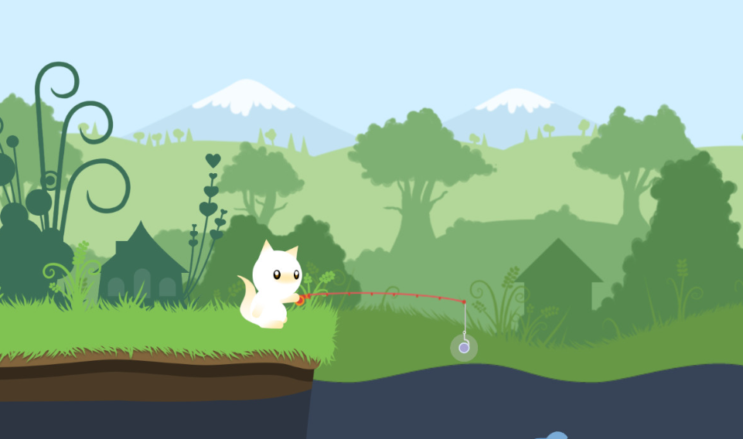

Requirements

Requirement 1: For the game to be easy to understand.
Explanation: Having the game be easy to understand means that it’s accessible and inclusive for many different people who will end up playing it. This could include but is not limited to younger children, people who are not computer illiterate, or even the elderly. However this doesn’t mean the gameplay itself is easy to play, but instead focuses on the controls and the understanding of the objective of the game.
Evidence: Initial orange section of the client interview, and question 4,6,7 of the questionnaire.
Requirement 2: Have the game be about a cat causing chaos
Explanation: As presented in the transcript, my client and I decided on a game based on a cat who’s mission is to essentially destroy their owners house. My client has a cat herself which is where this idea could’ve stemmed from.
Evidence: Green section of the client interview.
Requirement 3: Incorporating a leaderboard system
Explanation: Having a leaderboard system enables my client and other end users to participate in competition against others without needing the game to be multiplayer, which as shown from my questionnaire, lots of people don’t like as they feel stressed. In addition to competition, having a leaderboard systems allows me to program a reward system for the top users. This further encourages users to play in order to get the rewards, and adding an incentive makes playing the game feel productive.
Evidence: Green section of the interview.
Requirement 4: Incorporating an account system
Explanation: Having this system allows users to have their own personal account where data such as their cat colours and high scores can be saved. This allows them to continue where they left off at a later date. Additionally, having a customizable username allows the leaderboard to display these names, meaning you can look at where your friends are and who is at the top.
Evidence: Green section of the interview
Requirement 5: Having a constant 2D pixellated cat theme.
Explanation: Having a consistent theme in the game allows it to feel more professionally made. This theme will include the leaderboard’s design and account creation interface’s design, as well as any buttons or other objects.
Evidence: Purple section of the interview
Requirement 6: Creating animations
Explanation: Animations can make a game appear much higher quality as well as being more enjoyable. Having a character’s movement be just one frame makes it appear low effort which would be detrimental to my client’s enjoyment.
Evidence: Purple section of interview
Requirement 6: Having a friend system
Explanation: This will be a system where the user will be able to add or remove friends, and accept or decline friend requests. The friends must be displayed clearly on screen, potentially with additional information like their highscore, or active cat colour.

Objectives

Must
1. The game must be able to be played on a computer.
a. Game should run on any computer with the updated python and Pygame on it.
2. The program needs to be robust and run smoothly, with minimal (if any) bugs or crashes.
a. Program should have minimal FPS lagg when it is being run.
3. The program must have a easy to use, accessible interface with a consistent theme / colour scheme
a. User needs to be able to enter details such as username/password into the system.
b. User needs to be able to easily click with a mouse to navigate the program.
c. Interface and game needs to have a clear cat theme.
d. Everything must accessed through a series of menus recorded on a stack so user can go back as they please
4. The game must have a secure account system.
a. A hash table must be used to store hashed passwords securely.
b. User should be able to create an account and be automatically logged in with no past data
c. Program needs to verify the entered password is equal to the hashed password of the account before allowing user to login.
d. User should be told if either the username or password in invalid.
e. A minimum of 7 characters and a number should be the minimum security and the program should tell the user to enter a new password if it does not meet those requirements
f. Data of the accounts should be instantly retrieved and loaded when logged in.
5. A leaderboard which displays the top scores alongside the account username.
a. Leaderboard must be nice aesthetically
b. All high scores of every user must be stored into the SQL table, however only the top 10 will be displayed on the interface.
c. Top 10 scores must be displayed in descending order through use of SQL SORT
6. A character which is customizable.
a. Must be easily be able to changed through an option on the menu.
7. A character with animated movement
a. Every action (walk, crouch, run, idle) should have animations, and all animations should be the same for each colour design.
8. Classes for objects like buttons/textboxes/sprites as many will be created.
a. These classes must contain single-purpose subroutines and be as robust as possible.
Should
1. Be compiled into a single executable file.
a. This can be done through the use of pyinstaller – it can be difficult to compress a python script as well as images and sounds all into one executable file so I’ll do this if I have time.
2. Have custom designed buttons and backgrounds.
a. These will be on theme.
3. Have animated objects (Background/items in game, buttons, leaderboard, etc)
4. Have sound effects
a. Background music for the menu/game
b. Effects for breaking objects/cat meow/new high scores
5. Gameplay which is effortless to understand and enjoyable
6. A character with easy to understand and use controls
Could
1. Have a staggered character colour system where you need to unlock them through points.
2. Display the higher and lower scores of the user’s high-score on the leaderboard or the place they are
3. Have a section dedicated to explaining controls
4. Be able to mute sound effects or music.
5. Have a friend system where you can add another user from entering their username
a. Be able to view friend profiles which display their active avatars and high scores.
5. Have an animated interface.

Modelling

In order to create some initial models which will help support my design phase, I decided to focus on creating a first draft of the classes I know I will need.
A sprite class is necessary for my game as I may need to create multiple for when the screen changes, as well as it needing to take inputs in order to move the sprite around. Additionally, one of my important objectives is to animate the sprite during movement and abilities, and from my Pygame research I have learnt that it is easier, and the code is cleaner, when a class is used to implement this.
My button class and textbox classes are relatively simple, with the only difference being when the button is clicked, it will return true in order to change the screen state to a different state, producing a different interface for the user to use. This differs from the textbox class, where when clicked, will enter an “Active” state in order to allow the user to enter in text.
For the attributes, only an x coordinate and y coordinate in needed for all of those sprites, as in the program I will take the dimensions of the image provided in order to produce the width and height of the object.
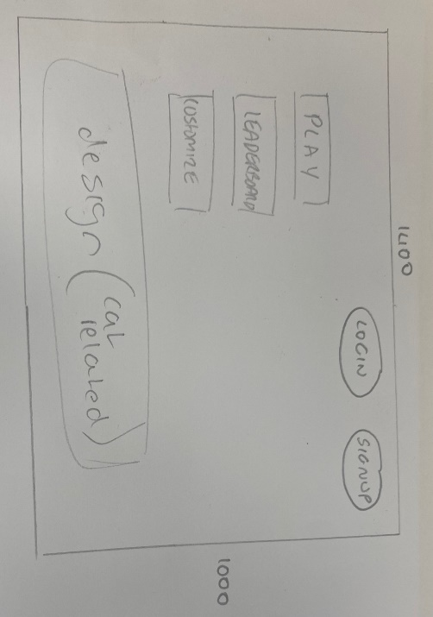
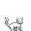
This is an example of the design of the sprite which will be implemented into the game. I downloaded a sprite sheet for most animations apart from the action I’ll design for when the cat interacts with an object. As the cat is white, I will be able to colour in the cat as I please. This will be time consuming as there is 21 tiles in total, so I may do this as one of my last tasks. The cat’s image size is 32x32 which I can take into consideration when designing the program. I intend to make the cat be able to crouch to fit into certain places, therefore I can change the height of the rectangle to 20 pixels or so without changing the actual image, so the cat only goes into the crouching animation and doesn’t actually get physically smaller.
I also designed a very basic interface for what I want the loading screen of the game to be. I’ve drawn simple rectangles where I want the play, leaderboard and customize buttons to be as well as buttons top right for the login and signup options. Additionally, there is a lot of blank space so I’m going to design a cat based image for the bottom of the screen. I aim to make it animated, but am not sure what I’ll do yet. Additionally, I may need to add a ‘mute’ button somewhere for all the sound effects in the game, or I may implement that in the ‘Account’ section.
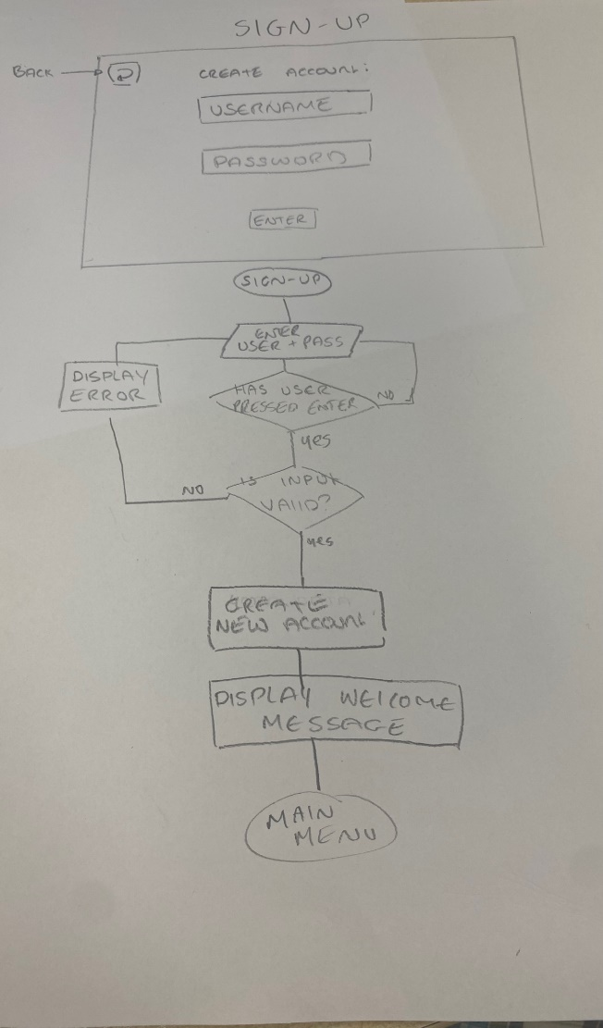
I also decided to draw a diagram and interface
for my ‘sign-up’ screen. This would be similar to the
login screen I also designed however would have
a few differences.
For both screens, I wanted them to have the same
background colour but with different designs. For
example, with the log-in screen, I sketched a small
floral pattern onto the background. I haven’t yet
decided on what I want for the signup screen, but
I was thinking about suns, stars and clouds or I could
make it cat themed with paw prints, collars and
mice/fish. This creates a differentiation between
the two menus despite them otherwise looking
quite similar, as I want it to be clear to the user which
screen they are on.
Another difference is that after the user enters the
username and password they intend to use, the sign-up
menu will first check if this username is in the database
already. If it is, an appropriate error message will be
displayed and nothing will happen, so the user is free
to try a different username. Additionally, if the username
does not exist, however the password is weak, a different
error message will be displayed and no account will be
created. Finally, if valid data is entered, a new, blank account
will be created and added to the database, with the user’s
password being hashed, and the user will be free to play
the game.
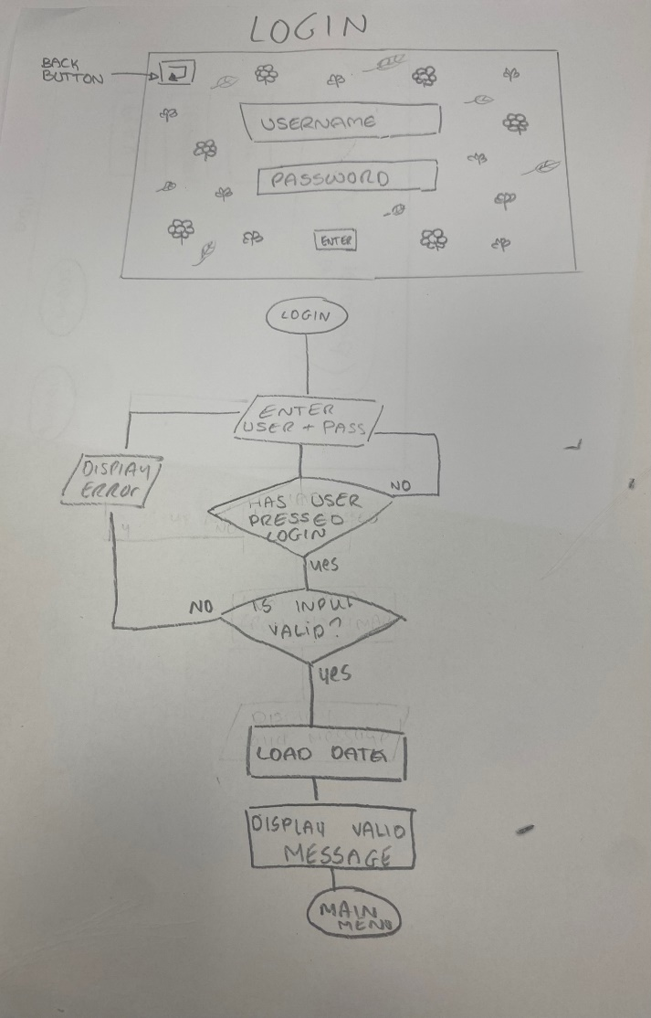

For the login menu, the program will wait for the user to click the enter button before validating the data. If there is no username in the system under that name, the appropriate error message will be displayed. If there is an account, but the password typed isn’t equal to the hashed password in the database, the user will be told this and denied entry. Once valid credentials are entered, the necessary data will be loaded from a database containing the user’s high score and active cat colours.
At any point during the login program or the signup program, if the user wants to go back, they are able to click the back button top left. Once clicked, the program will return to the Main menu.
If not logged in, the user will still be able to play the game, but will be stuck on the default cat colour (white) and will be unable to save their high score. They will also still be able to view the different options of cat colours, despite not being able to play as any of them, and be able to view the leaderboard.

Design

Database design and relationships

As I am developing an account system which saves data from the user’s gameplay, a database which takes these inputs, stores them, and is able to be updated is necessary. Aswell as just storing the gameplay data, the implementation of a friend system will also require a separate database to list all the friendships.

Accounts
Field | Data type | Description / Use
UserID | Integer | Primary key, used as a unique identifier for each account, and as a foreign key for other tables.
Username | Varchar(16) | Unique name, not a primary key as user is able change username. Chosen by user, can be letters or numbers. Used primarily in the friend system
Password | String | A hashed version of the password that the user entered when making account.

For the account table, the only fields needed are the primary key (UserID), username, and password.
The implementation of the unique identifier is vital as it’s role in defining relationships between tables ensures that data is consistent and reliable across the database. Although users cannot have the same username, the UserID field is separate as it cannot change, and the user may be able to change their username if I have time to code this.
Across the whole program, the plaintext password that the user enters is not stored. This is crucial in order to improve security, as storing the passwords of users poses the risk of a data breach. However, storing the hashed password is necessary in order to have something to compare the user’s input to when they login, therefore only the hashed password will be stored in the table. When a user creates an account, before a new record is added to the table, the password will be checked to see if it is secure enough. At a minimum, this password has to be above 7 characters and have at least 1 letter and at least one number. The account will not be created and the user will be notified of their error if an unsecure password is attempted.
Additionally, the username of the user will also be validated. It will not have any alphanumerical constraints, however will also have a minimum of 7 letters and a maximum of 16.

AccountData
Field | Data type | Description / Use
UserID | Integer | Foreign key referenced from Accounts table.
Username | Varchar(16) | Account username referenced from Accounts table.
Highscore | Integer | Initial value will be 0, and will be updated as user plays. Used to keep track of the user’s highest score in order to display a leaderboard.
SkinData | Varchar(6) | When user starts, data will be ‘100000’, with each letter showing if a colour is unlocked. If all skins are unlocked skinData will read ‘111111’ . Used for the program to know which skins to allow the user to select.
ActiveSkin | Integer | This will be the index of the skin list which the user currently has active. Used to update the in game sprite to the correct images.

Similar to Accounts, the account data has UserID. This is a foreign key used to link accountData and Accounts. Although the ‘Username’ field is not required for this table, it was more efficient to implement it as it meant I could select both the username and highscore in the same execution and store them in the same variable when selected which made fetching the data for the friend list and leaderboard much more robust.
The field Highscore is used in order to store what the user’s highest score in the game is. This is so the program can reference this data when the user clicks to the ‘customize’ screen, as the program will update the field SkinData depending on how big Highscore is. Additionally, the Highscore field can be sorted by ascending in SQL in order to select both the username and highscore of the top ten players, as well as selecting and displaying the user’s own score. The highscore field is also displayed on the ‘Friend’ menu in order for the user to keep updated with their friend’s high-score in order to encourage competitiveness.
The SkinData field is a string of 0s or 1s, where 1 references an unlocked skin and 0 is a locked skin. On the customize screen, the program will select the user’s SkinData and allow access to the skins in the skin list where the index of the skin is a 1 at the same index in SkinData. In order to update skinData,, when the user opens the customize screen, the program will select the user’s highscore and change the indexes of the skinData depending on if the highscore is higher than the value needed for each skin.
ActiveSkin is single integer which references the index of the skinlist where the skin which the user has selected is. This is used to update the cat sprite images when the user plays the game, aswell as display the active colour on the user’s friend’s friendlists.

Friendships
Field | Data type |  | Description / Use
FriendshipID | Integer | Primary key, unique identifier for each friendship as individuals will have multiple friends.
User1ID | Integer | Foreign key from Accounts. Needed to retrieve list of friends for each individual and display the usernames on that individuals friend screen.
User2ID | Integer | Foreign key from Accounts

As each user may have many friends, a primary key for each friendship is needed. If a user wants to delete a friend off their friendlist, the FriendshipID is selected and used to delete the record.
User1ID and User2ID are both foreign keys from the Accounts table. This is used in the friend screen, where a list of the user’s friends are created from where one of these values is equal to the user’s userID. This list is then used to retrieve the user’s highscore, skindata, and username to display it on screen.

FriendRequests
Field | Data type |  | Description / Use
RequestID | Integer | Primary key, unique identifier for each request as an individual may have sent several requests or have several pending requests.
TargetUserID | Integer | Foreign key from Accounts. Needed to be able to recall any pending requests that the target user has in order to display them and to create a new record in Friendships if target user accepts.
RequestingUserID | Integer | Foreign key from Accounts. Needed to create a record with the requesting users ID & the target’s if the target accepts. Also needed in order to retrieve the requested user’s username to display it for the target user.

The RequestID field is used because each user may have many requests, a primary key for each request is needed.
When a user clicks onto the friend screen, a program will search this table where the user’s userID is equal to the TargetUserID. The program will then select the RequestingUserID and then find the username of the user who sent the friend request in order to display it as a pending friend request and allow the user to either decline or accept the friend request.

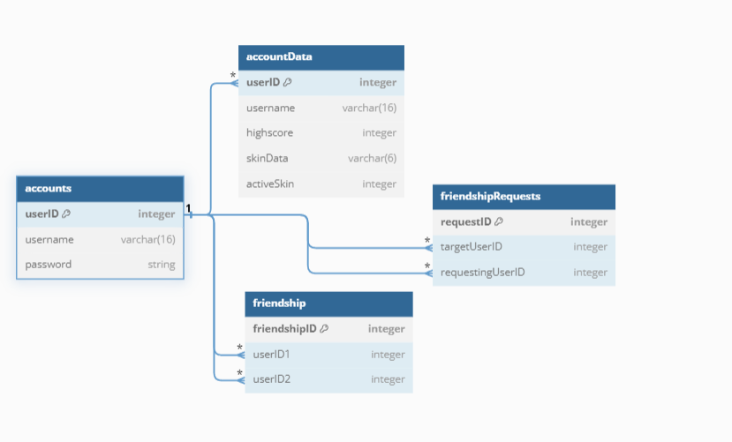
This diagram displays the relationships between the tables in my database. It shows how all of the tables are connected by the primary key ‘UserID’.

Sample of Possible SQL Queries
Creating a new account in Accounts
INSERT INTO accounts(userID, username, password) VALUES (?, userUsername, userPassword)

Creating a new account in accountData
INSERT INTO accountData(userID, username, highscore, skinData, activeSkin) VALUES (?, userUsername, 0, ‘00000’, 0)

Updating a new highscore
UPDATE accountData
SET highscore = newHighscore
WHERE userID = accData[0]

Selecting top 10 highscores
SELECT (username, highscore)
FROM accountData
ORDER BY highscore DESC
LIMIT 10

Selecting the userIDs who have sent friend requests to user
SELECT (requestingUserID)
FROM friendRequests
WHERE targetUserID = accData[0]

Stepwise Refinement
Menu screen – logged out
0. Run intro
1. Main Menu
1.1 Change display
1.2 Display buttons (Login, Signup, Play, Customize, Leaderboard)
1.3 Run on-screen animation
2. Login
2.1 Change display
2.2 Display textboxes
2.3 Allow user to enter credentials
2.4 Validate credentials
2.4.1 Check username exists
2.4.2 Hash entered password
2.4.3 Compare hashed password to password in table
2.5 If incorrect:
2.5 Display correct error message
2.6 If correct:
2.6.1 Select userID from Accounts
2.6.2 Select and return all details from AccountData
2.6.3 Split into list where each detail can be accessed through an index.
2.6.4 Assign to accData variable.
2.7 Return user to menu screen
2.8 Set logged = true.
3. Signup
3.1 Change display
3.2 Display textboxes
3.3 Allow user to enter credentials
3.4 Validate credentials
3.4.1 Check username does not already exist in database
3.4.2 Check username is > 7 characters
3.4.3 Check password contains numbers and letters and is > 7 characters.
3.5 if incorrect:
3.5.1 Display corresponding error message
3.6 If correct:
3.6.1 Hash entered password
3.6.2 Create new record in Accounts with userID, username and the hashed password
3.6.3 Create new record in AccountData with userID (foreign key), username, and blank data.
3.6.4 Display confirmation message.
4. Play
4.1 Display error message – Login to play.
5. Customize
5.1 Display error message – Login to customize.
6. Leaderboard
6.1 Change display
6.2 Fetch top ten highscores
6.2.1 Select username and highscore from accountData, order by DESC.
6.2.2 Convert into array
6.3 Display top 10 scores

Menu screen – logged in
1. Main menu
1.1 Change display
1.2 Display buttons (Login, Signup, Play, Customize, Leaderboard)
1.3 Run on-screen animation
1.4 Display user’s active cat
1.4.1 Set image index of on-screen cat to index of activeSkin (accData[4])
2. Log out
2.1 Set accData to empty list
2.2 Set LoggedIn = False
2.3 Change display
3. Friends
3.1 Change display
3.2 Display textboxes and buttons
3.3 Allow inputs into textboxes.
3.4 Check if user has any requests
3.4.1 Select requestingID from friendshipRequest where targetUserID = userID.
3.4.2 Store all returns into a list.
3.4.3 Display these names one at a time on screen
3.4.4 Allow user to reject or accept each request.
3.5 Display user’s friends on list
3.5.1 Select username, active colour and highscore of all user’s friend.
3.5.1.1 Get all IDs of user’s friends
3.5.1.2 Use IDs to get friend data
3.5.2 Assign data to textboxes and display
4. Play
4.1 Run game intro
4.2 Get game start time.
4.2.1 Display game timer
4.3 Load cat sprite
4.4 Change display to game
4.5 Check for collisions / actions
4.5.1 Add points to total score if object is broken
4.6 Check for screen changes
4.6.1 Change display and on-screen objects/platforms
4.7 When game ends:
4.7.1 Display outro
4.7.2 Check for new highscore
4.7.3 Update highscore and display message if new score
5. Customize
5.1 Change display
5.2 Fetch user’s skinData
5.2.1 Update skinData through checking user’s highscore
5.3 Allow user to click on skins which are allowed.
5.4 If user clicks on a skin update activeSkin
5.5 Update cat sprite and on-screen menu cat.
6. Leaderboard
6.1 Change display
6.2 Fetch top ten highscores
6.2.1 Select username and highscore from accountData, order by DESC.
6.2.2 Convert into array
6.3 Display top 10 scores
6.4 Fetch user’s highscore
6.5 Display user’s highscore

Menu interface design

Game intro

Main menu

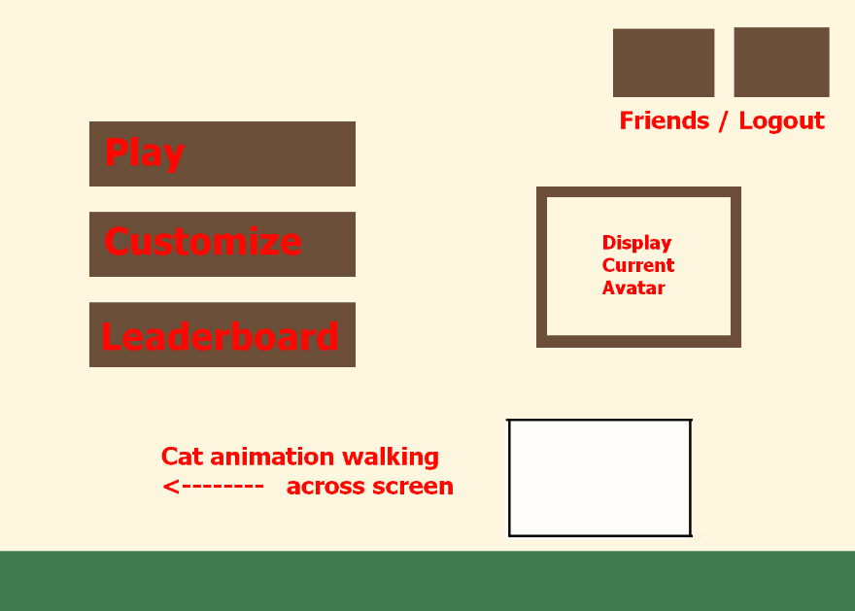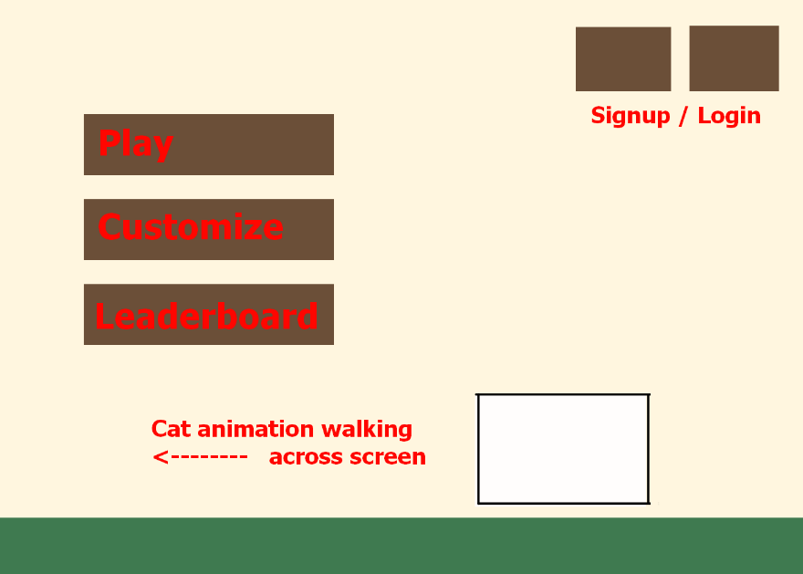

Login / Signup
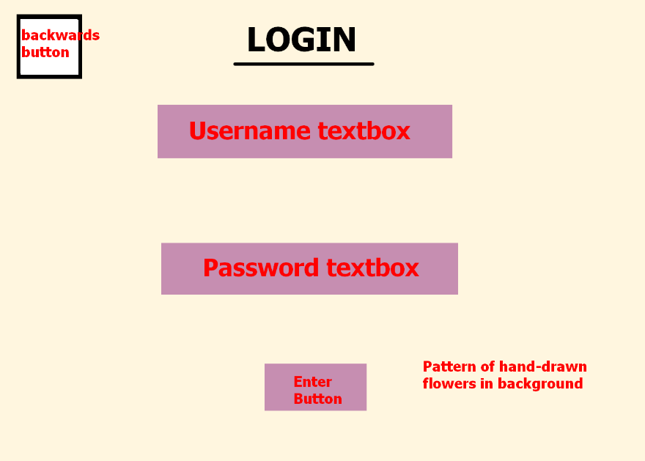
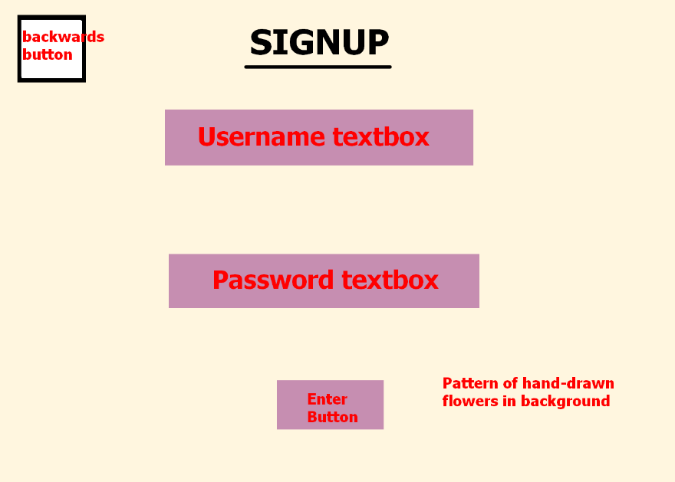

Customize
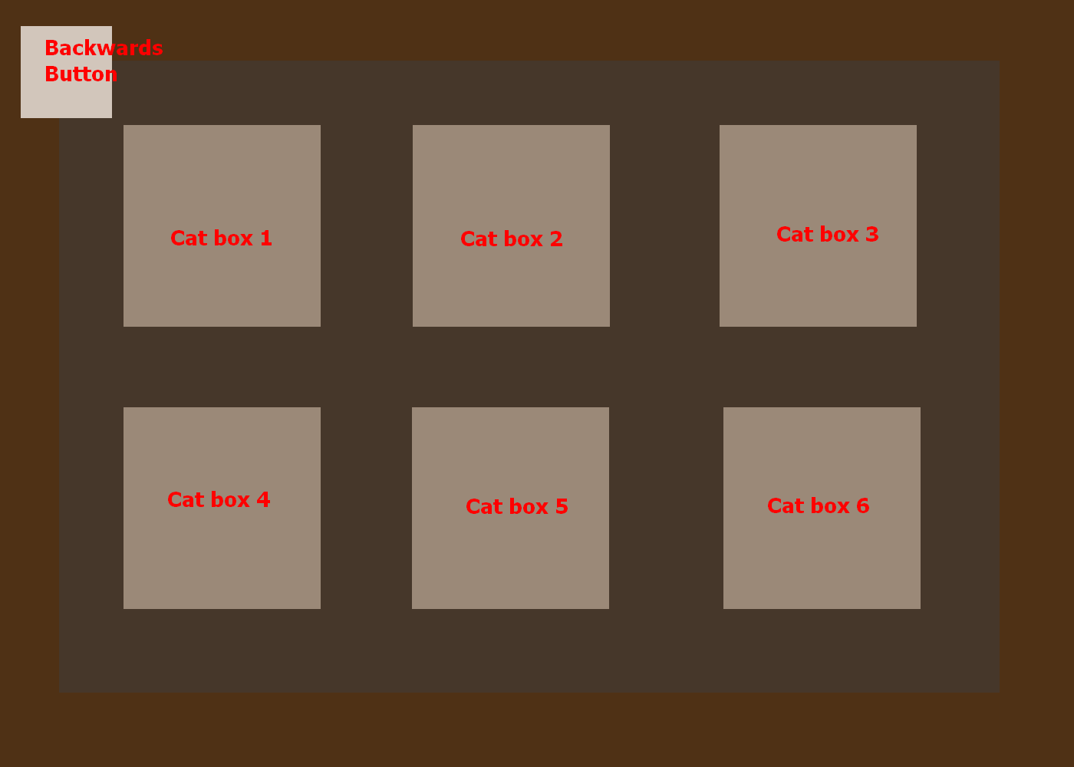

Leaderboard
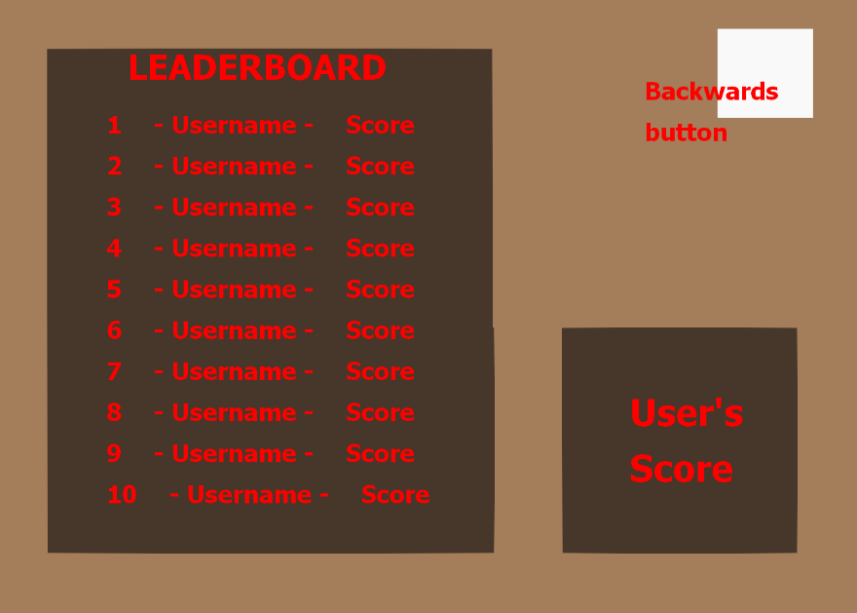

Friend screen
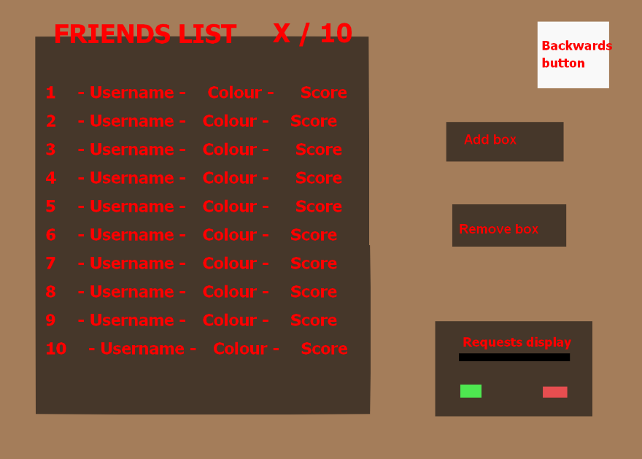

Navigation design

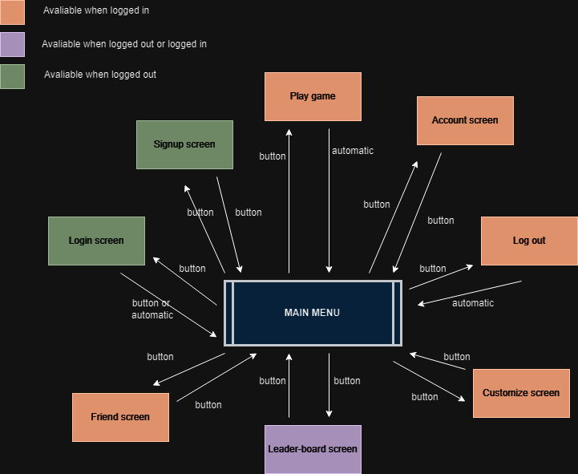

Class design

BUTTONS

The first class I decided to design was for the buttons needed to navigate the program as shown in my navigation design diagram. This class would need to do two main things; be drawn onto the main program on top of all other items, and be able to be clicked with a mouse in order to begin an action.

Purpose: Initialize the button class (Sub 1)
class button
private width image.width
private height image.height
private scale scale
private originalImage image
private image image * scale
private rect image.get_rect
private topleft x,y
public clicked False

Explanation: Width, height and scale are all necessary in order to take the image given to the class and stretch it proportionally to the correct scale necessary for the object to appear on screen at the right size. OriginalImage is needed for the ‘draw’ subroutine, where it needs to be referenced in order to adapt the image being drawn on screen without losing the original image to the adaptation. As apart of pygame, each object drawn on the screen needs to be assigned a rect, so the dimensions of the image are using in order to calculate the size of the rect. All of these attributes are private as they are not accessed outside of the subroutine, apart from ‘clicked’, which is a Boolean value and Is used to determine whether a user has clicked on the button.

Subroutine 2 - checkClicked
Purpose: To check if user has clicked on the button
sub checkClicked (event)
IF event = mousebuttondown and mousebutton = 1 THEN
IF self.rect.collide(event) and self.clicked = False THEN
clicked True
pygame.sound.play(sound)
ELSE
clicked False

Explanation: The event passed into the subroutine is checked to see whether the event is the mouse being clicked and if the button clicked is RMB. If this is false, then nothing in the object is changed, however if it is true, the algorithm checks if the area the button covers is colliding with where the event is happening (the mouse’s position) and if the button has not already been clicked. If this is true, the clicked attribute is changed to True and a sound is played. Otherwise, clicked is changed to False and the subroutine ends.

Subroutine 3 – Draw
Purpose: To draw the correct image onto the screen.
sub draw (surface, event, mousePos)
IF self.rect.collide (mousePos) THEN
self.image self.originalImage(width width+10, height height+10) * scale
ELSE
self.image self.originalImage * scale
checkClicked (event) Subroutine 2
surface.blit(self.image, (self.topleft))

return self.clicked
Explanation: First, the subroutine checks if the button’s rect is colliding with the mouse’s position (regardless of whether the user has clicked). If this is true, the scaled image being drawn is scaled by an additional 10 pixels. This makes the interface clearer to user who are less competent, as they will know whether the program will take the input for the correct button if they click.
If the mouse is not colliding, then the original image multiplied by the initial scale is drawn.
The program then runs the checkClicked subroutine in order to change the self.clicked value.
The image is then drawn on top of the rect, and self.clicked is returned to the main program.
In addition to the standard button class, another one would be needed for the customize screen. This is because the image drawn on the screen would be different depending on whether the user has unlocked or locked the skin.
Subroutine 4 - __init__
Purpose: Initialize the customizeButton class
class customizeButton
private width unlockedImage.width
private height unlockedImage.height
private scale scale
private originalImage originalImage
private activeImage lockedImage
private unlockedImage unlockedImage
private lockedImage lockedImage
private rect image.get_rect
public clicked False
public unlocked unlocked
public catID catID
Explanation: As this class is relatively similar to the previous one, I will only explain the variables which are different.
As the activeImage will change depending on whether the skin is unlocked, I made it a separate variable which will always be the image referred to when the image is drawn.
The unlocked and locked images are self explanatory, they are images which belong to the class and when drawn show a standard picture of the skin or a picture of the skin with the necessary points to unlock it drawn on top.
The Boolean ‘clicked’ attribute is used to tell the class whether or not the rect belonging to the image has been clicked, initiating an action to take place, (the action being changing the user’s active skin.). The unlocked attribute is public due to a subroutine in the main program comparing the user’s highscore to the needed points for each skin, and then changing the False to True if it meets the requirements.
The public catID attribute is referenced in the main program when the user clicks on it, as the
catID corresponding to the clicked button is what the user’s activeSkin data is changed to.

Subroutine 5 – handleEvents
Purpose: To handle if button is clicked
sub handleEvents (surface, event, mousePos)

IF event = mousebuttondown and mousebutton = 1 THEN
IF self.rect.collide(event) and self.clicked = False THEN
clicked True
pygame.sound.play(sound)
ELSE
clicked False

Explanation: This subroutine is identical to the equivalent subroutine in the previous class.

Subroutine 6 – Draw
Purpose: To draw button on screen with the correct image depending on state.
sub draw (surface, event, mousePos)
IF self.unlocked THEN
handleevents() Subroutine 5
self.activeImage self.unlockedImage
ELSE
self.activeImage self.lockedImage

IF self.rect.collide (mousePos) and self.unlocked THEN
surface.draw(activeImage(width width-10, height= height-10))
ELSE
surface.draw(self.activeImage * scale)
Explanation: The first if statement references the self.unlocked attribute which is changed depending on if that skin is unlocked in the main program. If it is set to True, then the object’s active image is changed to self.unlockedImage, otherwise is is self.lockedImage
The drawn image, when the mouse hovers on it, is set to only change if the object is unlocked. This is because I want to omit any confusion which could occur from hovering over a locked item, even if the locked image is being displayed. Additionally, as the space between the skin’s images and their borders is relatively small, I wanted to change it so the skin image shrinks slightly instead of increases in size, to prevent the image going over the border whilst still retaining the clarifying movement.

Character Class

Constants needed:
CAT_WIDTH 14
CAT_HEIGHT 13
GRAV 5

skinList [“white”,”calico”,”gray”,”tortoise”,”black”]
Explanation: For the width and height of the sprite, it always remains the same due to the images being essentially the same sprite except recoloured. Providing it a constant/global value means it does not need to be entered in the class’s parameter. Additionally, the gravity will be the same for every cat created and will not change throughout the program.
The skinList is a list of strings which correspond to the folder name containing all images of the appropriate skin colour. Having it as a string in a list means I can use an index to refer to each item, as well as joining the item to a path directory when images need to be fetched from the computer’s files.

Subroutine 7 - __init__
Purpose: To initialize the class
class catChar (x, y, colourID, scale)
private width CAT_WIDTH * scale
private height CAT_HEIGHT * scale
private x x
private y y
public rect Pygame.rect(x,y,width,height)
private scale scale
private colourID int(colourID)
private colour skinList[colourID]
private jumpCount 45
private vel_y 0
private FLOOR y + height

private Moving False
private Left False
private Sprint False
private isJump False
private isCrouch False
public attack False
private onPlatform False

private idleAnimation idleImageList (self.colour)
private walkAnimation walkImageList (self.colour)
private jumpAnimation jumpImageList (self.colour)
private crouchAnimation crouchImageList (self.colour)
private runAnimation runImageList (self.colour)

private current_sprite 0
private image idle[current_sprite]
Explanation: The black section is used to initialise the attributes which refers to the rectangle/positioning of the cat sprite, as well as what the size and colour of it is. Having an attribute of scale allowed me to efficiently test different sizes to see which fits best without the need to rescale each image individually every time. Additionally, jumpCount, vel_Y and FLOOR all refer to controlling the rate at which the sprite falls or rises when the space bar is pressed. I wanted the jump to be non-linear, with the sprite pausing very briefly, this is made easier by making the jumpCount an attribute instead of a variable in a subroutine as the rate at which the cat descends/ascends changes with each run of the program.

The blue section is a set of Boolean values which is referred to when the program wants to know the state of the cat. (Whether it is sprinting, jumping, on a platform, ETC) The attack variable is accessed externally when the game is run, to check if the cat is colliding with any objects whilst the attack variable is true/user has clicked RMB. The states are also uses to determine what animations need to be run.

The orange section is a simplified version of loading the images. In actuality, all images will need to be loaded individually, but this will be done by concatenating the self.colour string with a file path which is identical for all images. I have minimized the amount of frames needed for each animation in order to reduce the amount of images needed to be loaded every time the cat’s colour changes, whilst still retaining the fluid motion I want.
Finally, the green section is used to actually track and change the animated frame of each cat, by iterating through the animation lists with the index depicted in current_sprite.

Subroutine 8 – changeColour
Purpose: To change the sprite’s colour
Sub changeColour (colourID)
Self.colour skinList[colourID]

idleAnimation idleImageList (self.colour)
walkAnimation walkImageList (self.colour)
jumpAnimation jumpImageList (self.colour)
crouchAnimation crouchImageList (self.colour)
runAnimation runImageList (self.colour)

Explanation: This subroutine takes the new colourID from the main program and uses it as an index for skinList, where the corresponding string is assigned to self.colour in order to reload the images for the animation lists in the update colour.

Subroutine 9 – collisions
Purpose: To check for collisions with objects
Sub collisions (objectRect, dx, dy)

FOR each IN objectRect
IF self.rect.bottom <= each.top THEN
IF self.left THEN
self onPlatform True
dy each.top – self.rect.bottom
self.vel_y 0
self.isJump False

ELSE:
IF each.rect.collide(self.rect + (CAT_WIDTH * self.scale) ) THEN
self.onPlatform True
dy each.top – self.rect.bottom
self.vel_y 0
self.isJump False
Explanation: This subroutine receives a list of objects which are currently active on screen. These are the platforms which the cat should be able to jump onto, while still passing through if theyre jumping up through them. To do this, the collisions subroutine needs to be run after the expected pixels the cat will move in the next frame dy is calculated. This dy is then added to the cat’s current pixels to calculate whether the cat’s next movement will collide with the object. If it will, then the dy is set to 0 and returned to the movement subroutine, where the cat’s position on the screen will remain unchanged. The calculation is different for if the sprite is looking left due to the image always being drawn from the top left hand corner despite if the cat is facing right. This means that, without this adjustment, the cat would fall off too early on one side and too late on the other.

Subroutine 10 – ability
Purpose: To allow user to use abilities
Sub ability (event)
Key_pressed key.get_pressed

IF key_pressed = s and self.onPlatform THEN
self.y += 1
self.onPlatform True

IF event = mousebuttondown and button = 1 THEN
self.attack True

ELSE
self.attack False

Explanation: This subroutine is used to check for any actions the user might be performing. This is the attacking or dropping from a platform. The subroutine will take ‘event’ as a parameter, which in the main program is used to fetch all active events occurring, including mouse clicks and key presses. The algorithm will then use multiple if statements to check if the event’s contents is equal to the appropriate buttons that are pressed for these actions. If the RMB is being clicked, attack is set to true, if the s key is pressed whilst the cat is on a platform, the cat will drop from the platform.

Subroutine 11 – movement
Purpose: To allow user to move sprite
Sub movement (event, objectRect)
dx 0
dy 0
key_pressed key.get_pressed

IF key_pressed = d THEN
dx += 1.5
self.left False
self.moving True
ELIF key_pressed = a
dx -= 1.5
self.left True
self.moving True
ELSE:
self.moving False

IF key_pressed = Lshift THEN
dx *= 1.7
self.sprint True
ELSE
self.sprint False

IF key_pressed = c THEN
self.isCrouch True
dx *= 0.1

IF not self.isJump THEN
IF key_pressed = space THEN
self.isJump True

IF self.isJump THEN
IF self.jumpCount >= -45 THEN
isJump True
self.vel_y self.jumpCount * GRAV * -0.5 / 15
self.jumpCount -= 0.5

ELSE
self.jumpCount 45
self.isJump False
dy self.vel_y

IF not self.isJump THEN
self.jumpCount 45
self.vel_y += 2
IF self.vel_y > 13 THEN
self.vel_y 13
dy += self.vel_y * GRAV * 0.1

IF self.rect.bottom + dy > self.FLOOR THEN
self.rect.bottom self.FLOOR
dy 0

self.collisions(objectRect,dx,dy) Subroutine 9

self.y += dy
self.x += dx

Explanation: This subroutine allows the user to move the cat sprite across the screen during the game. The dx/dy variables are used to show the amount of pixels the sprite will move for the next frame, and this is added to the self.x/self.y attribute at the end of the subroutine after all checks and changes are made to it, Including checking for collisions. When the cat is moving left, dx will be less than 0, when the cat is moving right, dx will be above 0. This is the same for dy, where if the cat is moving down, dy will be positive. This is different to expected because Pygame’s window works in a where the window, and all rectangles/images are drawn from the top left instead of the usual bottom left.
The standard amount of pixels the cat will move per frame is 1.5 whilst walking, however this will be multiplied by 1.7 if isSprint is true in order for the cat to move 2.35 pixels per frame. Additionally, if the user is crouching then dx will be multiplied by 0.1 for 0.15 pixels per frame.

The jump action was difficult to code, and took a lot of trial and error. In order to prevent the cat from being able to double/triple/infinite jump, the program will only take action when the user presses space if the isJump attribute is set to false. This attribute is only set to false when the previous jump which was initiated is finished.
As I wanted the jump to be non-linear, with the initial and final dy being much greater than the slightly pause in the middle of the jump, self.vel_y (which is what dy is changed to) is calculated with a separate attribute of the class, jumpCount, which is the variable used for the calculation to occur. JumpCount is adjusted by 0.5 for each pixel, and starts from 45 and ends at -45, meaning it is changed 180 times, meaning for 180 frames the cat is jumping. If jumpCount was not a separate variable, then the jump would not be able to be a symmetrical, linear progression, as if the calculation was based off vel_y dy would progress in a linear line .
When jumpCount reaches less than -45, which means it has finished the jump, jumpCount will be set back to 45 in order for the cat to be able to jump again, whilst isJump is also set back to False.

Additionally, if the cat fell/jumped off an object, gravity would have to take place or else the cat would be stuck in mid air even after the jump ended. For this to work, much like real life, the gravity would constantly be working on the cat, trying to pull it down, however if the cat is on a platform or on the ground, this would override the gravity of dy trying to take place and change dy to 0 so the cat does not fall through the screen’s floor. Additionally, gravity does not take place on the cat whilst the cat is jumping, as if this occurred then the cat would not be able to jump.

To do this, the algorithm implementing gravity is run before the collisions subroutine is called and the check for if the cat + dy would be through the FLOOR attribute, and the algorithm is only run if isJump is false.

Subroutine 12 – update
Purpose: To update the sprite’s current image in order to animate.
Sub update (event)
Current self.idleAnimation

IF self.isJump THEN
current self.jump
ELIF self.moving
IF self.sprint THEN
current self.runAnimation
ELSE
current self.walkAnimation
ELIF self.isCrouch:
Current self.crouchAnimation

self.current_sprite += float(current[-1])
IF int(self.current_sprite) >= len(current) – 1 THEN
self.current_sprite 0
self.image current[int(self.current_sprite)]
self.rect pygame.rect((self.x,self.y),(width,height))
Explanation: The first actions this subroutine performs is to assign the animation list for Idle to the local Current variable. This is so the idle animation is always played if nothing is happening. This happens as the first line in order for the other calculations to be able to override this decision if appropriate.
For all of the jump, walk, run, and crouch animations, the corresponding Boolean variable is run and if this value is true then Current is changed to the animation list of that Boolean value.
At the end of each animation list is a float value which refers to how fast the animation should change. This is because I wanted the ‘run’ animation list to run faster than the ‘walk’ list or the ‘idle list. This also allowed me to easily play around with what I wanted the correct speed to be.
By using a small float value (0.01, 0.05, etc), the animation frame is not changed for every frame of the game. This is because the game is run at over a hundred frames per second, and if the animation image was changed every frame then the animation being run would be at a ridiculous speed.
self.current_sprite is incremented by this small value for every run of the subroutine (every frame), which means that it will slowly be increased. Self.current_sprite is then used as an index for the current animation list and this image is assigned to self.image. Finally, in order to prevent the index becoming eventually out of range (and to reset the animation to the first image), self.current_sprite is set to 0 if it is greater than the length of the animation list (-1 because of the float value ending it)

Subroutine 13 – draw
Purpose: To draw an the sprite onto the screen
sub draw (surface, event, objectRect)
self.movement(objectRect) Subroutine 11
self.ability(event) Subroutine 10
self.update(event) Subroutine 12

IF self.left THEN
surface.draw(flip(self.image))
ELSE
surface.draw(self.image))
Explanation: This subroutine is the one called in the main program when the cat is actively on screen. This means it is used to run all the movement, ability and update subroutines, as well as flipping the image is self.left is true.
It takes the parameters event and objectRect, as objectRect is needed to check for any collisions, and event is needed for the actual movement of the cat as well as actions like attacking.

Object class

Class initialization – objectSolid – Subroutine 14
Purpose: To create a solid platform which the user can jump onto.
class objectSolid ( x, y, image, scale)
private scale scale
private x x
private y y
private imagePNG Pygame.image.load(“Props/”+image+”.png”)) * scale
public rect pygame.rect(x,y,width,height)

Explanation:
Scale is used to transform the image by a easily changeable size whilst keeping the quality the same.
x & y are both used for the positioning of the object.
ImagePNG is the PNG of the image of the platform.
rect is public in order to be used for collision checking whilst the game is playing.

Subroutine 15 – draw
Purpose: To draw the object
Sub draw (surface)
Surface.blit(self.imagePNG, (self.x,self.y))

Explanation:
Draws the image in the correct position onto the screen.

Class initialization – objectPoints – Subroutine 16
Purpose: To create and draw an interactable object which the aim is to break to add points to the user’s total.
class objectPoints (x, y, image, scale, noise, value)
private scale scale
private x x
private y y
private image image
private imageOrig pygame.image.load(“Props/”+image+”.png”) * scale
private imageBroken pygame.image.load(“Props/”+image+”A.png”) * scale
private width imageOrig.width
private height imageOrig.height
public rect pygame.rect(x,y,width,height)
public broken False
private noise noise
private value value
public points 0

Explanation:
Scale is used to transform the image by a easily changeable size whilst keeping the quality the same.
x & y are both used for the positioning of the object.
ImageOrig is the unbroken version of the object, whereas imageBroken is the appearance of the object after it has been attacked by the cat.
Both rect and broken are public, as rect is accessed in other areas when collisions are checked, and broken is used to see which image needs to be displayed as well as checking whether points are due to be added to the user’s running total.
Noise is the sound which needs to be played when the object is broken.
Value is the amount of points added to the total when the object is broken. This will be of 3 variants, 25, 50 and 100.

Subroutine 17 – handleEvents
Purpose: To check whether the user is attempting to break the object.
Sub handleEvents (surface, attack, catrect)

IF catrect.colliderect(self.rect) THEN
IF attack THEN
1 IF NOT self.broken THEN
Pygame.mixer.sound.play(self.noise)
Self.points self.value
Self.broken True

2 Self.draw(surface) Subroutine 18
Explanation:
1 – This section of code checks the current location of the rect representing the user’s sprite (cat), and if this rectangle is colliding with the rect of the object it will proceed. If the cat is attacking and the object is not already broken, then the correct sound of the object will play aswell as a value being assigned to self.points, which is what the main program checks when adding points to the total.
2 - This calls subroutine 2 which draws the object on the screen, it is important this is after the previous algorithm, because the image drawn depends on whether or not the object is broken

Subroutine 18 – draw
Purpose: To draw the appropriate image onto the screen.
sub draw (surface)
IF self.broken THEN
1 Self.image self.imageBroken
ELSE
Self.image self.ImageOrig

2 Surface.blit(self.image,(self.x,self.y)

Explanation:
1 – This algorithm changes the self.image attribute depending on whether or not the image needs to be appear broken.
2 – This is the actual statement which draws the updated image in the correct positioning.

Textboxes

Constants needed
Purpose: To establish a constant font which is used, aswell as the list of 5 type sounds for when the user types a key, and the clickSound
Base_font pygame.font(‘november’,65)
Secondary_font pygame.font(‘november’,30)

clickSound pygame.mixer.Sound(“music/clickSound2.wav”)

typeSound1 - 5 pygame.mixer.sound(“music/typeSound1-5.wav”)

typeSoundList = [typeSound1, typeSound2, typeSound3, typeSound4, typeSound5]

Class initialization – Textbox – Subroutine 19
Purpose: To initialize the attributes of the class.
Class textbox (x, y, image, scale, smallerFont)
Private width image.width
Private height image.height
Private scale scale
Private image image
1 Private rect image.get_rect
Private rect.topleft (x,y)
2 Private text = ‘ ‘

3 IF smallerFont THEN
Private text_surface secondary_font.render(self.text)
ELSE
Private text_surface base_font.render(self.text)

4 Private active False

Explanation:
1 – Creates a rectangle of the textbox’s width, height and positioning
2 – Creates an attribute of the text which is being written inside of the textbox.
3 – As the textboxes are used for the login/signup, and the friend screen, these require only 2 different sizes of text, so rather than making a new font for each object I decided to just have two variants.
4 – Used to represent whether or not the user is actively typing something into the textbox.

Subroutine 20 – reset
Purpose: To reset the self.text attribute.
Sub reset (self)
Self.text ‘ ‘
Explanation: Self explanatory

Subroutine 21 – Type
Purpose: To receive the key(s) the user is typing and append them to self.text
Sub type (surface, event, key)
1 IF self.active THEN
2 IF key = pygame.K_BACKSPACE AND len(self.text) > 0 THEN
Pygame.mixer.sound.play(typeSoundList(randint(0,4))
Self.text = self.text[:-1]
3 ELIF key = pygame.K_RETURN THEN
Self.active False
4 ELIF len(self.text) < 16 THEN
Self.text += key
IF key != ‘ ‘ THEN
Pygame.mixer.sound.play(typeSoundList(randint(0,4))

Self.draw(surface,event) Subroutine 23
Explanation:
1 – Checks whether or not the textbox is active before proceeding with appending. If I didn’t have this, any letters the user typed would append letters to every textbox on screen.
2 – If the user presses backspace, the most recent letter is removed from the self.text attribute and a sound is played.
3 - If the user presses return, self.active is set to false and they cannot type anything else into the textbox unless they click on it again.
4 – This initially checks whether or not the length of self.text is greater than 16, and does not allow any keys to be typed if so. This is because the maximum password length / username length a user can enter has 16 letters, and throughout the entire program the only things that need to be typed are usernames and passwords. Therefore there is no reason for the user to be able to type more than 16 letters.
After this has been validated, the key will be appended to self.text, and a random type noise in the list of noises will be played.

Subroutine 22 – handleEvents
Purpose:
Sub handleEvents (surface, event, key)
1 Self.type(surface,event,key) Subroutine 21
IF event.type = pygame.MOUSEBUTTONDOWN THEN
2 IF self.rect.collidepoint(event.pos) THEN
Pygame.mixer.sound.play(clickSound)
Self.active True
ELSE
Self.active False

3 Return self.text
Explanation:
1 – Runs the self.type function.
2 – Checks whether or not the user has clicked onto the textbox, and if so sets self.active to True. If the user clicks off the textbox, this is also coded to set self.active to False.
3 – This program will always return self.text to the main program as this is what is recorded when the user entering details.

Subroutine 23 – Draw
Purpose:
Sub draw (surface, event)
1 IF self.active THEN
Image Pygame.transform.scale(self.image(self.width*self.scale*1.5,
self.height*self.scale*1.5))
ELSE
Image Pygame.transform.scale(self.image(self.width,self.height)

2 IF self.smallerFont THEN
Self.text_surface secondary_font.render(self.text,true,COLOUR)
ELSE
Self.text_surface base_font.render(self.text,true,COLOUR)

3 Surface.blit(image,(self.rect.x,self.rect.y)
Surface.blit(self.text_surface,(self.rect.x,self.rect.y))
Explanation:
1 – If the textbox is active, then the image which will e drawn is updated to be slightly larger. This is so there is a visual difference for the user so they know which box they are typing into.
2 – The text surface is updated here with the newly written text.
3 – Both the image and text are drawn here

Cutscene class

Constants
Purpose: For a screen
SCREEN Pygame.display.set_mode(1400,1000)
Explanation: The screen itself

Class initialization – cutscene - Subroutine 24
Purpose: To initialize the class.
class cutscene (x, y, numOfFrames,, speed, scale)
1 private numOfFrames numOfFrames
2 private type type
3 private scale scale
7 public onscreen False

private frameX x
private frameY y
4 private image ‘ ‘

5 private currentFrame 0
private animationSpeed speed

6 FOR I IN RANGE(numOfFrames)
self.frameList.append(Pygame.image.load(“Cutscene/”+type+I)
Explanation:
1 - Represents the number of images in the total scene.
2 – Is what the cutscene is of, e.g. ‘Outro’, ‘Intro’
3 – Scale of the images
7 – Whether or not the image needs to be draw on screen.
4 – The current image being drawn on screen
5 – The current frame number and the speed of the animation. I made the speed an attribute so I could easily adjust it to test what is the ideal speed for it to be run at.
6 – This essentially goes into the folder named ‘cutscene’ where all the images for every cutscene are located. Each frame is named ‘Type’ + ‘Num in sequence’, for example ‘Outro6’ would be the sixth frame in the outro sequence. This for loop gets every image in the folder and appends them to the frameList.

Subroutine 25 – getFrame()
Purpose: To set self.image to the next frame.
Sub getFrame(self)
1 Self.currentFrame += float(self.animationSpeed)

IF self.currentFrame >= len(self.frameList) THEN
Self.currentFrame 0
Self.onScreen False

Self.image self.frameList[int(self.currentFrame)
Explanation:
1 - self.currentFrame is incremented by the small value in self.animationSpeed for every run of the subroutine (every frame), which means that it will slowly be increased. Self.currentFrame is then used as an index for the frameList and this image is assigned to self.image. Finally, in order to prevent the index becoming eventually out of range, self.current_sprite is set to 0 if it is greater than the length of the animation list and self.onScreen is set to false as the animation will have been completed.

Subroutine 26 – Draw
Purpose: To call getFrame() and draw the current image on screen.
sub play (SCREEN)
self.getFrame() Subroutine 25

IF self.onScreen THEN
SCREEN.blit(self.image,(self.frameX,self.frameY))
Explanation:
Runs self.getFrame() in order to update self.Image to the appropriate frame. It is then drawn in the correct position.

Algorithm Design

Constants

Purpose:
SCREEN_WIDTH 1400
SCREEN_HEIGHT 1000
SCREEN Pygame.display.set_mode(SCREEN_WIDTH,SCREEN_HEIGHT)

BLANKEVENT pyame.event(event.custom())
pygame.display.set_caption(“CATASTROPHE”)

CAT_WIDTH 14
CAT_HEIGHT 13

skinList [“White”,”Calico”,”Gray”,”Tortoise”,”Black”]

menuMusic menuMusic.mp3
gameMusic ameMusic.mp3

gameLoad cutScene.cutscene(0,0,78,’gameLoad’,0.4,1)

Explanation:
The width, height, and the Screen display itself are set to constants throughout the program as they will never be changed. This is the same with the width and height of the cat, as 14 and 13 represent the number of pixels of the image.
The menuMusic and gameMusic also have no need to be changed so are set at constants.

MANY OBJECTS ARE ALSO DEFINED HERE! ABOUT 50! BUT I AM NOT TYPING ALL THAT!

SQLite3 Table/Database creation

Purpose
dataConnection SQLITE3.connect(‘AccountData’)
dataCursor dataConenction.cursor()
Explanation:

Purpose: Create accounts table
dataCursor.execute(“””
1 CREATE TABLE IF NOT EXISTS accounts (
Id INTEGER PRIMARY KEY NOT NULL,
username VARCHAR(16) NOT NULL,
password VARCHAR(16) NOT NULL )
“””)
Explanation:
1 – As this program will be run multiple times, the ‘IF NOT EXISTS’ is vital as otherwise hundreds of tables will be created.
2 – I have limited username and password to Varchar(16) as I wanted tot limit the size of username/password able to be typed, as I know the person playing my game will want to be annoying and make a three hundred character username. Additionally, it is set to VARCHAR and not string because the 16 characters should be a limit not a minimum.

Purpose: Create accountData table.
dataCursor.execute(“””
CREATE TABLE IF NOT EXISTS accountData (
Id INTEGER PRIMARY KEY NOT NULL,
username VARCHAR(16)
highscore INT NOT NULL,
skinData VARCHAR(5) NOT NULL,
activeSkin VARCHAR(1) NOT NULL,
FOREIGN KEY (ID) REFERENCES accounts(ID) )
“””)
See Database Design and Relationships

Purpose Create friendRequests table
dataCursor.execute(“””
CREATE TABLE IF NOT EXISTS friendRequests (
requestID INTEGER PRIMARY KEY NOT NULL,
requestingUserID INT NOT NULL,
targetUserID INT NOT NULL )
FOREIGN KEY (requestingUserID) REFERENCES accounts(ID),
FOREIGN KEY (targetUserID) REFERENCES accounts(ID),
“””)
See Database Design and Relationships

Purpose: Create friendList table.
dataCursor.execute(“””
CREATE TABLE IF NOT EXISTS friendList (
friendshipId INTEGER PRIMARY KEY NOT NULL,
user1ID INT NOT NULL,
user2ID INT NOT NULL,
FOREIGN KEY (user1ID) REFERENCES friendRequsts(requestingUserID),
FOREIGN KEY (user2ID) REFERENCES friendRequests(targetUserID)
)
“””)
See Database Design and Relationships

Main menu

Subroutine 26 – mainMenuDraw
Purpose: To draw the main menu and take inputs of which buttons have been clicked.
sub mainMenuDraw (event, mouse_pos, state_stack, loggedIn)
startTime None

2 FOR error IN errorList
IF error.errorOn = True THEN
error.draw(SCREEN,event,mouse_pos)

IF PlayButton.draw = clicked THEN
IF loggedIn THEN
state_stack.append(“play”)
1 startTime time.get_ticks
gameIntro.onScreen True
music.pause
ELSE
loginToPlay.error True

IF customizeButton.draw = clicked ELSE
IF loggedIn THEN
state_stack.append(“customize”)
ELSE
loginToCustomize.error True

if leaderboardButton.draw = clicked
state_stack.append(“leaderboard”)

3 IF not loggedIn THEN
IF loginButton = clicked THEN
state_stack.append(“login”)

IF signupButton = clicked THEN
state_stack.append(“signup”)
ELSE
IF logoutButton.draw = clicked THEN
state_stack.append(“logout”)

IF friendsButton.draw = clicked THEN
state_stack.append(“friends”)

return state_stack, startTime
Explanation: This subroutine is used in order to draw all of the buttons on screen which allows the user to navigate the game.
2 -The for loop which handles the errors works through checking all of the possible errors that exist in the program and checking whether the attribute ‘errorOn’ inside of each error is set to True. If it is set to true, it will be drawn onscreen until the user clicks it once, which causes ‘errorOn’ to be set to false and for the image to no longer be drawn on screen.

1 - All of the if statements which make up the drawing of the buttons work as if theyre clicked, the class will return true which allows for the program to continue and append to the state_stack. Additionally, when the user clicks play, a timer will start which is used to calculate how much time the user has left. This is done through getting the inital amount of ticks that the program is on and minusing that from the current amount which finds the amount of time the game has been run for.

3 - Additionally, the program takes the ‘loggedIn’ boolean variable in order to know which buttons need to be displayed. This is because when the user is logged in, different buttons need to be drawn on screen, so the program will only run those button’s ‘draw’ function if the loggedIn variable is set to True

Where subroutine 26 is called
Purpose: To handle the main menu screen through the main game loop
1 IF menu_state = “main” and gameOutro.onScreen = false THEN
2 IF loggedIn THEN
Background mainBackground2
ELSE
Background mainBackground

3 mouse.set_visible

4 menuCat 1 -> 4 .draw(SCREEN)

5 state_stack, startTime mainMenuDraw( event, mouse_pos, state_stack, loggedIn) Subroutine 26
Explanation:
1 – This if statement is used to check if the state of the game needs to be the main menu. Additionally, it will not proceed with the subroutine whilst the game’s outro is playing, as if it did then the buttons and other text would be drawn over the outro.

2 – This statement is used to know which background to draw. The loggedIn background differs to when the user isnt logged in due to there being an on-screen depiction of the current avatar the user has chosen.

3 – This is used to return the mouse visibility, which is turned off whilst the game is being played.

4 - This draws the on screen animation of the cat’s walking at the bottom of the screen.

5 – This runs the subroutine above, and has the updated state_stack and the startTime returned to it. If the user doesn’t press play, then startTime will be ‘None’, and the state_stack is used to assign the updated version to ‘menu_state’ in order to know which according actions need to occur.

Gamestates

Constants
SCREEN Pygame.display.set_mode(1400,1000) 1

kitchenBackground pygame.image.load("images/kitchenBackground.png") 2
bedroomBackground pygame.image.load("images/bedroomBackground.png")
loungeBackground pygame.image.load("images/loungeBackground3.png")
bathroomBackground pygame.image.load("images/bathroomBackground.png")

crashSound pygame.mixer.Sound("music/crashSound.wav") 3
foodSound pygame.mixer.Sound("music/foodSound.wav")
metalSound pygame.mixer.Sound("music/metalSound.wav")
paperSound pygame.mixer.Sound("music/paperSound.wav")
bookFallSound pygame.mixer.Sound("music/bookFallSound.wav")

soundList [crashSound,foodSound,metalSound,paperSound,bookFallSound]
4
backgroundList [kitchenBackground,loungeBackground,bedroomBackground, bathroomBackground]
Purpose:
1 – As the gamestates is coded in a separate file, SCREEN is reinitialized here.
2 – The background for the current game states is assigned here.
3 - The five sounds for different objects being broken are assigned here. These will be sourced later on.
4 – Lists for the background and soundList are created so I can package the date and unpack it in the subroutines through using indexes.

Example of object loading
Purpose: To load the objects and platforms for each screen and return them.
sub objectLoad_____()
object = objectClass.objectPoints(x,y,imageName,scale,soundList[n])
1
platform = objectClass.objectSolid(x,y,imageName,scale)

2 _____Obj = [object]
_____Plat = [plat]

Return _____Obj, _____Plat

Explanation:
This is just an example for each of the gameStates, as the code is identical apart from which objects are created and the names. Substitute any of the gameState names into ______ and the object and platform variables at (1) are just a demonstration of how each are assigned, aswell as put into the list at (2)

Example of state being run
Purpose: To draw and handle the events for every platform and object on the screen
sub _____(SCREEN, event, Cat, _____Obj, _____Plat)
Pygame.mouse.set_visible(False)

1 FOR obj IN _____ Obj
obj.handleEvents(SCREEN, Cat.attack, Cat.Rect)

2 FOR plat IN _____Plat
plat.draw(SCREEN)

3 cat.draw(SCREEN,event,_____Plat)

return BackgroundList

Explanation:
This is just an example for each of the gameStates, as the code is identical apart from which objects are created and the names
1 – Checks every object to see if the cat’s current rect is colliding and if the cat is attacking.
2 – Draws every platform in the platList
3 - passes the platlist to the cat class in order to check for any collisons that could be occurring.

Play

Purpose: To check if the user is logged in so they can play, change the music and run the game/post-game itself.
IF menu_state = “play” THEN
IF loggedIN THEN
IF NOT Pygame.mixer.music.get_busy() THEN
1 Pygame.mixer.music.load(gameMusic)
Pygame.mixer.music.set_volume(0.15)
Pygame.mixer.music.play(0)

2 IF NOT gameIntro.onScreen THEN
Sub 27 gameState, background, POINTS, seconds playGame (gameState, SCREEN, event, catAvatar, objList, platList, POINTS, startTime)

3 state_stack, gameState, objList, platList, catAvatar postgame(seconds, Sub 32 state_stack, POINTS, accData, gameState, objList, platList, catAvatar)
ELSE
Pygame.mixer.music.unpause()
State_stack.pop()
Explanation:
1 – Checks whether or not MenuMusic is playing. If it is not playing, gameMusic is loaded onto the mixer channel and the volume is adjusted. This is then played.
2 – After the game intro is done, the playGame() subroutine is run, which returns the gameState,background,POINTS and seconds. The gameState and background are use to keep track on which game state the cat is currently in. The POINTS is constantly kept track of due to it being a running total. The seconds variable refers to how long the game will be running for. This is passed to postgame, where the game ending will be handled if seconds exceeds the amount of time the game runs for.
3 – platList and objList and catAvatar are all returned by postgame() as this subroutine handles resetting them in order for the user to be able to play a new game.

Subroutine 27 – playGame
Purpose: To check what the current gameState is and run the appropriate subroutine for each state.
sub playGame(gameState, SCREEN, event, catAvatar, objList, platList, POINTS, startTime)
1 seconds (Pygame.time.get_ticks() – startTime) / 1000

2 IF gameState == “kitchen” THEN
Background gameStates.kitchen(SCREEN,event,catAvatar,objList[0],platList[0]) Sub 31 gameState, POINTS handleKitchen(gameState, POINTS, catAvatar)
ELIF gameState == “lounge” THEN
Background gameStates.lounge(SCREEN,event,catAvatar,objList[0],platList[0])
Sub 30 gameState, POINTS handleLounge(gameState, POINTS, catAvatar)
ELIF gameState == “bedroom” THEN
Background gameStates.bedroom(SCREEN,event,catAvatar,objList[0],platList[0])
Sub 29 gameState, POINTS handleBedroom(gameState, POINTS, catAvatar)
ELIF gameState == “bathroom” THEN
Background gameStates.bathroom(SCREEN,event,catAvatar,objList[0],platList[0])
Sub 28 gameState, POINTS handleBathroom(gameState, POINTS, catAvatar)

Return gameState, background, POINTS, seconds
Explanation:
1 – Used to calculate the amount of seconds the game has been running for. This is done by minusing the startTime (recorded in ticks) by the current ticks and dividing it by 1000.
2 – These if/ELIF statements check what gameState is equal to, then will run the corresponding gameStates subroutine which will draw all the platforms, check if the cat has interacted with any breakable objects, and also draw the cat whilst checking for collisions.

Subroutine 28 – handleBathroom
Purpose:
Sub handleBathroom(gameState,POINTS,catAvatar) THEN
1 IF catAvatar.x <= -81 THEN
gameState gameStateList[2]
catAvatar.x 1400

2 IF catAvatar.x+20 >= 1430 THEN
gameState = gameStateList[0]
catAvatar.x -80

3 FOR obj IN objList[3]
POINTS += obj.points

Return gameState, POINTS
Explanation:
1 – if the cat avatar goes off screen on the left side, then the game state will change to the previous item in the gameStateList, and the catAvatar’s x positioning will be changed to the far right of the screen.
2 – if the cat avatar goes off screen on the right side, then the game state will change to the next item in the gameStateList, and the catAvatar’s x positioning will be changed to the far left of the screen
3 – The objList of the subroutine’s gameState is iterated through, and any points due to be added to POINTS are added.

Subroutine 29 – handleBedroom
Purpose:
Sub handleBedroom(gameState,POINTS,catAvatar) THEN
1 IF catAvatar.x <= -81 THEN
gameState gameStateList[1]
catAvatar.x 1400

2 IF catAvatar.x+20 >= 1430 THEN
gameState = gameStateList[3]
catAvatar.x -80

3 FOR obj IN objList[2]
POINTS += obj.points

Return gameState, POINTS
Explanation:
1 – if the cat avatar goes off screen on the left side, then the game state will change to the previous item in the gameStateList, and the catAvatar’s x positioning will be changed to the far right of the screen.
2 – if the cat avatar goes off screen on the right side, then the game state will change to the next item in the gameStateList, and the catAvatar’s x positioning will be changed to the far left of the screen.
3 – The objList of the subroutine’s gameState is iterated through, and any points due to be added to POINTS are added.

Subroutine 30 – handleLounge
Purpose:
Sub handleLounge(gameState,POINTS,catAvatar) THEN
IF catAvatar.x <= -81 THEN
1 gameState gameStateList[0]
catAvatar.x 1400

2 IF catAvatar.x+20 >= 1430 THEN
gameState = gameStateList[2]
catAvatar.x -80

3 FOR obj IN objList[1]
POINTS += obj.points

Return gameState, POINTS
Explanation:
1 – if the cat avatar goes off screen on the left side, then the game state will change to the previous item in the gameStateList, and the catAvatar’s x positioning will be changed to the far right of the screen.
2 – if the cat avatar goes off screen on the right side, then the game state will change to the next item in the gameStateList, and the catAvatar’s x positioning will be changed to the far left of the

screen
3 – The objList of the subroutine’s gameState is iterated through, and any points due to be added to POINTS are added.

Subroutine 31 – handleKitchen
Purpose:
Sub handleKitchen(gameState,POINTS,catAvatar) THEN
IF catAvatar.x <= -81 THEN
gameState gameStateList[3]
catAvatar.x 1400

IF catAvatar.x+20 >= 1430 THEN
gameState = gameStateList[1]
catAvatar.x -80

FOR obj IN objList[0]
POINTS += obj.points

Return gameState, POINTS
Explanation:
1 – if the cat avatar goes off screen on the left side, then the game state will change to the previous item (or in this case, the last item as the rooms work as a loop) in the gameStateList, and the catAvatar’s x positioning will be changed to the far right of the screen.
2 – if the cat avatar goes off screen on the right side, then the game state will change to the next item in the gameStateList, and the catAvatar’s x positioning will be changed to the far left of the screen
3 – The objList of the subroutine’s gameState is iterated through, and any points due to be added to POINTS are added.

Subroutine 32 – postGames
Purpose: To handle events after the game has finished.
sub postgame (seconds, state_stack, POINTS, accData, gameState, objList, platList, catAvatar)

1 IF seconds > 23 THEN
Pygame.mixer.music.stop()
2 Pygame.mixer.music.load(menuMusic)
Pygame.mixer.music.set_volume(0.25)
Pygame.mixer.music.play()

3 gameOutro.onScreen True
state_stack.pop()

4 gameState, objList, platList gameReset(gameState) Subroutine 33
catAvatar charClass.catChar(600,840,accData[4],8)

5 IF POINTS > accData[2] THEN
UPDATE accountData SET highscore = POINTS WHERE username = accData[1])
newHighscore.errorOn True

return state_stack, gameState, objList, platList, catAvatar
Explanation:
1 – Compares the seconds variable which is passed to the subroutine with ‘23’. This is the length of the game + the 3 seconds the game intro takes. If the current seconds is greater than 23, then the rest of postgame subroutine will be run, otherwise any items passed to the subroutine will be returned unchanged.
2 – This section of code stops the gameMusic which is currently playing, then queues and adjusts the volume of menuMusic.
3 - This changes the onScreen attribute of the gameOutro object in order to begin the animation of the outro on screen. Additionally, state_stack is popped in order to return to the mainMenu, meaning the game is no longer being played.
4 - This calls Subroutine 33 which resets the objList, platList and gameState so the user is able to play the game again.
5 – This compares the user’s current highscore in their accData with the points they current gained. If their points are higher than their highscore then the highscore is updated and the newHighscore error is toggled to display on screen.

Subroutine 33 – gameReset
Purpose: To reset the object and platform lists in order for the game to be able to be played again
Sub gameReset (gameState)
kitchenObj, kitchenPlat gameState.objectLoadKitchen()

bedroomObj, bedroomPlat gameState.objectLoadBedroom()
1
loungeObj, loungePlat gameState.objectLoadLounge()

bathroomObj, bathroomPlat gameState.objectLoadBathroom()

objList = [kitchenObj, loungeObj, bedroomObj, bathroomObj]
2 platList = [kitchenPlat, loungePlat, bedroomPlat, bathroomPlat]

gameState = “lounge”
3 catAvatar.x = 600

return gameState, objList, platList
Explanation:
1 – These four statements reload all the objects and plats through using the subroutines in the gameStates section.
2 – Appends the updated object and platform lists into objList and platList
3 – Resets the cat’s x position to be central, and the gameState to be returned to Lounge, ready for the game to be restarted.

Customize

Subroutine 34 – customizeCat
Purpose:
sub customizeCat (SCREEN, event, mouse_pos, state_stack, accData, loggedIn)
1 IF customizeBackwardButton = clicked THEN
state_stack.pop

checkUnlocked (accData ) Subroutine 35

unlockSkins (accData ) Subroutine 36

2 FOR avatar IN customizeSelectList
IF avatar = clicked THEN
UPDATE accountData SET activeSkin = avatar.catID WHERE username = accData[1]

SELECT * from accountData where username = accData[1]

3 Return accData
Explanation:
1 – This is used to draw the backwards button on screen which allows the user to go back to the main menu, which is done by using the pop function on the state_stack list which removes the last item
2 - This for loop goes through all of the skins on the customize screen, even the ones which are locked. This is because, even if an avatar is locked, it should still be displayed on screen so the user knows which ones are avaliable. Despite being drawn, if the user clicks on it nothing which change and no noise will be played due to the fact that inside of the class, the function which allows the button to be clicked is only enabled when the ‘unlocked’ attribute is set to true.
3 - This returns the updated accData to the main program which allows the program to change the user’s active skin colour.

Subroutine 35 - checkUnlocked
Purpose: To check which of the skins the user is able to select.
sub checkUnlocked (accData)
1 highscore (SELECT highscore FROM accountData WHERE username = accData[1])

2 scoreList [500, 1000, 2000, 2500]
newSkinData ‘1’

FOR score IN scoreList
3 IF highscore > score THEN
newSkinData + ‘1’
ELSE
newSkinData + ‘0’

4 UPDATE accountData SET skinData = newSkinData WHERE username = accData[1]

Explanation:
1 - This returns the user’s highscore from the database.

2 – This set scoreList is what the user’s highscore needs to be higher than in order to unlock a skin. The index of each score is equivelent to the index one higher in the skinList, however as the white cat is the base skin and always unlocked, newSkinData starts at 1 and there is no minimun score needed.

3 – This loop and selection appends either 1 or 0 to newSkinData depending on whether the user’s highscore is higher than a score In scoreList. 1 means that the skin is able to be chosen whereas 0 means that the user’s highscore is too low and thus they are not able to select that skin.

4 – This SQL statement updates the database with the new skinData

Subroutine 36 – unlockSkins
Purpose: To unlock the skin objects depending on skinData’s contents
sub unlockSkins (accData)
1 skinData (SELECT skinData from accountData WHERE username = accData[1])

for i in range len(skinData)
2 IF skinData[i] = 1 THEN
customizeSelectList[i] unlocked
ELSE:
customizeSelectList[i] locked

Explanation:
1 – This statement retrieves the skinData from accountData. This subroutine is run after the checkUnlocked subroutine as that is where the skinData gets updated.

2 – This section iterates through the skinData string, and depending on whether the index = 1 or 0, updates the object in customizeSelectList of equivelent index and changes it’s attribute ‘unlocked’ to True

Where subroutine 34 is called
Purpose: To run the customize screen
If menu_state = “customize”:
1 accData customizeCat(SCREEN,event,mouse_pos,state_stack,loggedIn,accData,
keyPressed)
2 background customizeBackground
3 catAvatar.changeColour(int(accData[4]))
Explanation:
1 – Runs the customizeCat subroutine and has the updated accData returned to the main program.

2 – Updates the screen’s background to the correct image

3 – Changes the catAvatar’s colour, which is displayed on the main menu for the user to know which of their avaliable skins is active.

Leaderboard

Subroutine 36 - handleLeaderboard
Purpose: To retrieve and display highscore data.
Sub handleleaderboard (SCREEN, event, mouse_pos, state_stack, loggedIn, accdata, keyPressed)
1 IF loggedIn THEN
2 Score (SELECT highscore FROM accountData WHERE username = accData[1])

3 IF int(score) < 1000 THEN
userHighscore.handleEvents(SCREEN,data)
ELSE
userHighscore.x = 1025
userHighscore.scale = 2
userHighscore.handleEvents(SCREEN, data)

4 topTen (SELECT username, highscore FROM accountData ORDER BY highscore DESC).fetchmany(10)

5 FOR I IN RANGE len(topTen)
leaderboardUserText[i].handleEvents(SCREEN,str(topTen[i][0]))
leaderboardScoreText[i].handleEvents(SCREEN,str(topTen[i][1]))

IF leaderboardBackwardButton = clicked THEN
state_stack.pop
loaded False
Explanation:
1 – The leaderboard is a feature which is accessible for any user regardless of if they’ve logged in or not. However, if the user isn’t logged in then there will obviously be no high score to display on the screen, therefore this selection is used to stop the program searching for account data which isnt there.
2 – Retrieves the highscore belonging to the user.
3 – Necessary for scaling, printing the highscore needs to be centered, therefore if the user has a high highscore then the font size needs to be made smaller so it is cleaner looking.
4 – Sorts all records in the accountData table by descending order of highscore. The username and highscore of this top ten is then fetched and put into an array.
5 - The lists of objects containing the textboxs of the usernames and highscores are then iterated through and updated and drawn.

Where subroutine 36 is called
Purpose: To call change the background and call the subroutine for the leaderboard’s handling.
If menu_state = “leaderboard”
Background = leaderboardBackground
handleLeaderboard(SCREEN,event,mouse_pos,state_stack,accData,loggedIN)

Explanation: Self-explanatory.

Log In

Subroutine 37 – loginMenu
Purpose: To draw textboxes and retrieve their input
Sub loginMenu (SCREEN, event, mouse_pos, state_stack, keyPressed, login)
1 userUsername loginUser.handleEvents (SCREEN, event, keyPressed)
userPassword loginUser.handleEvents(SCREEN, event, keyPressed)

FOR error IN errorList
IF error.errorOn = True THEN
error.draw(SCREEN, event, mouse_pos)

2 IF enterButton = clicked THEN

3 IF validLogin (userUsername, userPassword, SCREEN, event, mouse_pos) Sub 38
login True
state_stack.pop
loginUser.reset
loginPass.reset
ELSE
login False

4 IF backwardButton = clicked THEN
loginUser.reset
loginPass.reset
state_stack.pop

5 IF login THEN
return userUsername, login, state_stack
ELSE
return EMPTY_STRING, login, state_stack

Explanation:
1 – These are the textboxes which continuously check for user input. Any text written into the box is updated to the variables userUsername / userPassword.
2 – The validation of the data only needs to occur when the user has finished entering data, which is signalled by them clicking the enter button.
3 – After the enter button has been pressed, the validLogin subroutine will occur. If this returns true, then the login variable will be set to true,e the contents of both the textboxes will be reset and the state_stack will be popped in order for the user to automatically return to the main menu screen.
4 – Used to return to the main menu screen without having to login. Contents of userUsername / userPassword are reset here aswell.
5 – If the user has logged in, the user’s username will be returned to the main program in order to continue the login process, however if the user isnt logged in then an empty string will be given in its place. Additionally, the login and state_stack variables need to be returned as they will have been updated.

Subroutine 38 – validLogin
Purpose: To validate the credentials the user has entered.
Sub validLogin (userUsername, userPassword, SCREEN, event, mouse_pos)

1 Result (SELECT EXISTS (SELECT id FROM accounts WHERE username = userUsername))

2 IF result = EMPTY_STRING THEN
noAccountFound.errorOn True

ELSE
encodedPassword hashlib.sha256(userPassword)
3
accountPassword (SELECT password FROM accounts WHERE username = userUsername))

IF encodedPassword = accountPassword THEN
return True
ELSE
return False

Explanation:
1 – This SQL statement fetches the userID of the account that the user has entered. This will return an empty string if there is no such account.
2 – If there is no account, then the noAccountFound error will be switched to true in order for it to be displayed on screen for the user to see.
3 - This section will only be run if the account exists. The program will hash the password the user entered on the login screen, then fetch the coded password from the accounts database. It will then compare both hashed passwords, and if they are equal then the validLogin subroutine will return True to the loginMenu subroutine.

Where subroutine 37 is called
Purpose: To receive the validated account and fetch the account’s data.
IF menu_state == “login” THEN
Background loginBackground

1 Account, loggedIn, state_stack loginMenu (SCREEN, event, mouse_pos, state_stack, keyPressed, loggedIn)

2 IF loggedIn THEN
3 accData (SELECT * FROM accountData WHERE username = account)

4 catAvatar charClass.catChar(600,840,accData[4],8)
currentAvatarDisplay catSprite.catSprite(840,320,15,”idle”,0,accData[4])

Explanation:
1 – Retrieves the validated account’s username, the state_stack, and the boolean value of loggedIn
2 – Only runs this section if the account the user entered is a valid account, and that they have the correct password. This prevents users from logging into accounts that arent theirs by mistake or maliciously.
3 – Fetches all fields in accountData belonging to that user.
4 – Updates the avatar being displayed on the main menu and the avatar which is used to play the actual game to the user’s active skin colour which is stored in accData[4]

Log out

Purpose: To erase loaded data and allow for new user to log in
IF menu_state = “logout” THEN
1 state_stack.pop
2 accData EMPTY_STRING
loggedIn False
Explanation:
1 – Pops “logout” from the state stack in order for the program to automatically return to the main menu in a logged out state.
2 - Erases all previous account data stored in accData so it is unable to be accessed, aswell as setting loggedIn to false so the correct buttons and actions that’s are needed for a logged out state to occur.

Sign up

Subroutine 39 – signUpMenu
Purpose:
sub signUpMenu (SCREEN, event, mouse_pos, state_stack, keyPressed)
1 userUsername signupUser.handleEvents(SCREEN,event,keyPressed)
userPassword signupPass.handleEvents(SCREEN,event,keyPressed)

2 FOR error IN errorList
IF error.errorOn = True THEN
error.draw(SCREEN, event, mouse_pos)

IF enterButton = clicked THEN

3 valid validSignup(SCREEN,userUsername,userPassword) Subroutine 40

4 IF valid = 0 THEN
createAccount(userUsername, userPassword) Subroutine 41

5 userUsername, userPassword EMPTY_STRING

6 IF backwardButton = clicked THEN
signupUser.reset
signupPass.reset
state_stack.pop
Explanation:
1 – These textbox objects are used to continuously check for user input, and assigns any string entered into the textbox into the userUsername / userPassword variables.
2 – This algorithm is identical to the previously explained algorithm in mainMenuDraw and loginMenu
3 – After the enter button is clicked, the current strings that are in userUsername and userPassword are passed into the validSignup subroutine which validates the information that the user enters. If there is no issues with the input and the account details are within the guidelines, then the subroutine will return ‘0’ which is assigned to the ‘valid’ variable.
4 - Here, the program checks whether or not the details entered have been returned as valid. If they are, the program will continue and pass the validated username and password to the createAccount subroutine, where the details will be put into the database.
5 – After the username and password has been sent to createAccount and that subroutine has been run, both userUsername and userPassword is set to an empty string. This allows the user to create another account if they wish.
6 – This allows for the user to return back to the main menu without creating an account. This may be necessary if the user has clicked on the wrong button or has decided against creating a new account. This section also resets signupUser and signupPass so they have no string stored in them and are ready to receive a new input if the user clicks back onto the signup screen.

Subroutine 40 – validSignup
Purpose: To validate the details the user has entered for an account to be created.
Sub validSignup ( SCREEN, userUsername, userPassword )
1 Valid (SELECT EXISTS ( SELECT 1 FROM accounts WHERE username = userUsername ))

2 IF valid = 1 THEN
accountAlreadyExists.error True
3 ELIF len(userUsername) <= 5
usernameTooShort.error True
valid 1
ELIF len(userPassword) < 7
unsecurePassword.error True
valid 1
ELIF userPassword.isalpha
unsecurePassword.error True
valid 1
ELIF userPasswprd.isnumeric
unsecurePassword.error True
valid 1

return valid

Explanation:
1 – This SQL statement searches the account database for an account which alreadyd has the username which the user has entered. This prevents multiple accounts with the same username from being created, which can result in issues when retrieving the accountData from the database.
2 – If an account with this username exists, ‘1’ will be returned to the ‘valid’ variable. An if statement will check this variable and if appropriate, the correlating error will be toggled on and displayed on screen, and ‘1’ will be returned to the main program which signals that account creation cannot take place.
3 – For all of the following if statements, they check whether or not the username/password meets the guidelines AFTER the program checks that the account does not exist. The appropriate error message will be toggled on if needed, and valid will be set to 1 and also returned to the main program.

Subroutine 41 – createAccount
Purpose: To hash the userPassword
Sub createAccount (userUsername, userPassword)
1 encodedPassword hashlib.sha256(userPassword)

2 INSERT INTO accounts (id, username, password) VALUES (NULL, userUsername, encodedPassword)

3 INSERT INTO accountData (id, username, highscore, skinData, activeSkin ) VALUES (NULL, userUsername, 0, ‘00000’, ‘0’)

Explanation:
1 – This takes the validated password which has been passed to it and encodes through hashing it.
2 – This creates a new record in the accounts table, where username = userUsername and password = the new, encoded password. I do not store the unhashed password as that poses a security risk.
3 - Similar to the previous line, this creates a new record in accountData, with completely blank game data (No highscore, base active skin and skindata)

Where subroutine 39 is called
Purpose: To call the signupMenu
IF menu_state = “signup” THEN
Background signupBackground
signupMenu(SCREEN, event, mouse_pos, state_stack,keyPressed) Sub 39

Explanation: Self explanatory.

Friends

Subroutine 42 – friendScreen
Purpose: To receive inputs and execute the correct response depending on what the user wants.
Sub friendScreen (SCREEN, event, mouse_pos, state_stack, accData, keyPressed)
1 targetUser addUserBox.handleEvents(SCREEN,event,keyPressed)
deletedUser removeUserBox.handleEvents(SCREEN,event,keyPressed)

2 IF friendBackwardButton = clicked THEN
addUserBox.reset()
removeUserBox.reset()
state_stack.pop()

3 friendUserList, friendHighscoreList, friendActiveCat getFriendlistData(accData) Sub 43

4 recieveRequests(accData, event, mouse_pos, friendUserList) Sub 44
displayFriends(accData, friendUserList, friendHighscoreList, friendActiveCat) Sub 45

FOR error IN errorList
IF error.errorOn = True THEN
Error.draw(SCREEN, event, mouse_pos)

5 IF friendEnterButton = clicked THEN
IF targetUser != EMPTY_STRING THEN
sendRequests(targetUser, accData, friendUserList) Sub 46
IF deletedUser != EMPTY_STRING THEN
deleteUser(deletedUser, accData) Sub 47

6 IF NOT addUserBox.active THEN
addUserBox.reset()
IF NOT removeUserBox.active THEN
removeUserBox.reset()
Explanation:
1 – These two interactable textboxes are used to receive input for when the user wants to either delete an existing friend or send a new friend request. These are constantly checking for inputs like key presses when they are active (clicked on) and immediately assign the new typed value to the appropriate variable.
2 – This button is used to allow the user to navigate back to the main menu through the simple press of a button. This also resets any inputs in both textboxes.
3 – This line is used to send the user’s account data to the subroutine getFriendListData in order to get the data needed to display the friend list. This includes the username, highscore and the active colour of cat that this account has on. This returns three separate lists which are then used update the textbox objects which correlate to the friends list display.
4 – This call to recieveRequests allow any pending friend requests to the user to appear on screen and allow the user to accept or decline. The call to displayFriends blits individual textboxes with the updated friend information on.
5 – This algorithm is run when the user presses the on-screen enter button. The program then checks whether or not there is any input in either of the available text boxes. If there is, then the appropriate subroutine will run and handle the input data.
6 – This code erases any input inside of the textboxes when the user clicks off them. – This might not be necessary as data is already erased once the user clicks the backwards button, but I will run some tests.

Subroutine 43 – getFriendlistData
Purpose: To run the necessary subroutines which return the three data lists needed for displaying friend list information.
sub getFriendlistData(accdata)
friendUserList getUsernameList(accData) Sub 48

friendHighscoreList getHighscoreList(friendUserList) Sub 49

friendActiveCat getActiveColour(friendUserList) Sub 50

return friendUserList, friendHighscoreList, friendActiveCat
Explanation:
I believe this subroutine is relatively self explanatory, however the running of getUsernameList() must be first due to the second and third subroutine needing these identifiers to reference for when they fetch their own data.

Subroutine 44 – recieveRequests
Purpose: To check for any existing friend requests in order to display them on screen and allow for user to accept or decline them.
sub receiveRequests (accData, event, mouse_pos, friendUserList):
requestsList [‘ ‘]
requestsBox.handleEvents(SCREEN,requestsList[-1]

userID accData[0]

1 IDList SELECT requestingUserID FROM friendRequests WHERE targetUserID = userID

2 IF len(IDList) NOT 0 THEN
avaliableRequests True
FOR I IN range len(IDList)
requestUsername SELECT username FROM accountData WHERE id = i
requestsList.append(requestUsername)
ELSE
avaliableRequests False

3 IF avaliableRequests THEN
requestsBox.handleEvents(SCREEN, requestsList[-1])

4 IF friendAcceptButton = Clicked AND avaliableRequests = True THEN
IF len(friendUserList) >= 10 THEN
tooManyFriends.errorOn True

ELSE
requestedID int(IDLIST[-1])

5 INSERT INTO friendList (friendshipID, user1ID, user2ID) VALUES (null, requestedID, userID)
6 IDlist.pop
requestsList.pop
DELETE FROM friendRequests WHERE requestingUserID = requestedID AND targetUserID = userID

7 IF friendDeclineButton = clicked AND avaliableRequests = True THEN
requestedID IDList[-1]
DELETE FROM friendRequests WHERE requestingUserID = requestedID AND targetUserID userID
requestsList.pop
IDList.pop

Explanation:
1 – This SQL statement selects all existing requestingUserIDs in the friendRequests table where the targetUserID is the user’s and has them in a list.
2 – If this list is not empty, then this IF statement will run and for every ID in IDList, it will fetch the corresponding username from the accountData database and append it to requestsList.
3 – Here, the most recently sent friend requests (the last one in the requestsList stack) will be displayed and will be the request that the user is able to accept or decline. This is done by updating the text in the object and calling the handleEvents function which includes drawing the text onto the screen.
4 – This IF statement will run if the user decides to click the accept request button whilst they have pending requests. Before it inserts a new record into the friendList table, the program will verify that the user has less than 10 friends by checking the length of friendUserList. If the user has 10 friends then an appropriate error message will be displayed on screen and they will be unable to accept the request, however this will not delete the request.
5 – This is run after the program has verified that the user has space on their friends list. A new record is made in friendList with the targetUser and requestingUser’s ID. In retrospect, if I have time I will re-code this so that the user with the smaller userID will always be user1ID as this will make searching for existing friends in other subroutines easier and less lines.
6 – These few lines, after adding the new friend record, will delete the top of the requestsList and IDList stack, aswell as deleting the record in friendRequests which relates to the request that the user has just accepted. This is necessary as without it, the friendRequests table may get excessively long if many users are sending many requests which forever stay in the table.
7 – This if statement is run if the user clicks the decline button. Similar to above, requestsList and IDList will be popped, however no new record will be made. Instead, the related record to the request in friendRequests will be deleted without a new record in friendsList being made.

Subroutine 45 – displayFriends
Purpose: To update the textbox objects needed to display the required information on screen.
Sub displayFriends (accData, friendUserList, friendHighscoreList, friendActiveCat)
1 friendUserText, friendScoreText, friendColourText friendListItems() Sub 51

friendAmount len(friendUserList)

2 FOR I IN range friendAmount
friendColourText[i].colour skinList(friendActiveCat[i]
friendUserText[i].handleEvents(SCREEN,friendUserList[i])
friendScoreText[i].handleEvents(SCREEN,friendHighscoreList[i])
friendColourText[i].draw(SCREEN)

3 numOfFriends.handleEvents(SCREEN,friendAmount)

Explanation:
1 – This subroutine call is used to retrieve the blank, textboxes used to display the username, score and colour of the user’s friends.
2 – This for loop runs for each friend the user has, and updates the appropriate textboxes with the friend’s information. This is then drawn through either the .handleEvents function for the textboxes or the .draw function for the catSprite.
3 – This is a textbox which displays the number of friends the user has in case they can’t count.

Subroutine 46 – sendRequests
Purpose: To send friend requests to a target user by creating a new record in the friendRequests table.
Sub sendRequests(targetUser, accData, friendUserList)
requestingUser accData[1]

1 error, targetID, requestingID checkRequestValidity(requestingUser, targetUser) Sub 52

2 IF error = False THEN

IF len(friendUserList) = 10 THEN
tooManyFriends.errorOn True
ELSE
3 INSERT INTO friendRequests (requestingUserID, targetUserID) VALUES (requestingUser, targetUser)
friendReqSent.errorOn True

Explanation:
1 – First, subroutine 11 will be run which checks the request’s validity. This includes whether the target user the friend has entered is a real user, a friend request to them has already been sent, or whether they are already friends. If the data entered is valid, ‘error’ will be returned as an empty string.
2 – This subroutine will only run if the data entered is valid. First, the program will check whether the user has 10 friends already. If they do, no friend request will be sent and the tooManyFriends error message will display on screen in order to allow the user to remove a friend if they deem necessary.
3 – This SQL statement creates a new record in friendRequests with the valid data, and displays a confirmation message afterwards saying that a friend request has been sent.

Subroutine 47 – deleteUser
Purpose: To allow the user to delete a friend off of their friends list.
Sub deleteUser (targetUser, accData)
error EMPTY_STRING
friendshipID EMPTY_STRING
deletingID EMPTY_STRING

1 deletingID, userID checkDeletionValidity (targetUser, accData) Sub 53

2 IF deletingID = EMPTY_STRING THEN
noAccountFound.errorOn True
ELSE
3 friendshipID getFriendshipID(deletingID,userID) Sub 54

4 IF friendshipID != EMPTY_STRING THEN
DELETE FROM friendList WHERE friendshipID = friendshipID
friendDeleted.errorOn True

Explanation:
1 – Sends the user’s data and the target user to checkDeletionValidity on order to verify that the request is valid. This means checking that the user the target has entered exists and is also on the user’s friend list.
2 – If deletingID is returned as empty, this means that there is no such user that the user has entered. This causes a noAccountFound error to be turned on.
3 – This subroutine call uses getFriendshipID to fetch the friendship ID in the friendsList database which represents the friendship between the user and the target user.
4 – This will only run if friendshipID is empty. If the friendship between the users doesn’t exist then the getFriendshipID subroutine will handle this and notify the user that the friendship doesn’t exist, and will return an empty string to friendshipID.
Then, using a SQL statement, the record with this friendshipID will be deleted from the friendList table and the user will be notified that the friendship has been deleted.

Subroutine 48 – getUsernameList
Purpose: To retrieve a list of usernames which the user is friends with.
Sub getUsernameList (accData)
userID accData[0]
friendIDList []
friendUserList []
1 friendIDs1 SELECT user1ID from friendList where user2ID = userID
friendIDs2 SELECT user2ID from friendList where user1ID = userID

2 IF len(friendID1) != 0 THEN
FOR friendID IN friendIDs1
3 friendUserList.append(SELECT username FROM accountData WHERE id = friendID)

IF len(friendIDs2) != 0 THEN
FOR friendID IN friendIDs2
friendUserList.append(SELECT username FROM accountData WHERE id = friendID)

return friendUserList
Explanation:
1 – Both of these lines do the same thing, except searching both user1ID field and user2ID. In retrospect, if I have time I will amend this to, when a new friendship is added to the table, the lower of both IDs will be assigned to user1ID. This line fetches all IDs of all the users who Is friends with this user.
2 – This will check if there is existing friends before running the for loop.
3 – This will go through every ID in the ID lists and fetch the usernames that correlate with this ID. These will all then be appended to a single, friendUserList which is the item which is returned to the previous subroutine.

Subroutine 49 – getHighscoreList
Purpose: To fetch a list of all the highscores of the friends of the user.
Sub getHighscoreList (friendUserList)
friendHighscoreList []
1 FOR I IN range len(friendUserList)
Highscore = (SELECT highscore FROM accountData WHERE username = friendUserList[i])
friendHighscoreList.append(Highscore)

return friendHighscoreList

Explanation:
1 – This for loop will iterate the length of friendUserList and find the highscore of user in every index. This highscore will then be appended to friendHighscoreList which is then returned to the previous subroutine.

Subroutine 50 – getActiveColour
Purpose: To fetch the active skin colours of every friend of the user.
sub getActiveColour (friendUserList)
friendActiveCat []

FOR I IN range len(friendUserList)
colour = (SELECT activeSkin FROM accountData WHERE username =
1 friendUserList[i])
friendActiveCat.append(colour)

return friendActiveCat
Explanation:
1 - This for loop will iterate the length of friendUserList and find the colour of user in every index. This colour will then be appended to friendActiveCat which is then returned to the previous subroutine.

Subroutine 51 – friendListItems
Purpose: To create the 20 textbox objects and 10 sprite objects needed to display the username, score, and colour of each friend.
Sub friendListItems()
1 friendUser1 -> friendUser10 = textBoxClass.textBoxSolid(165, (295 -> 705), ‘’, 0.45)

2 friendScore1 -> friendScore10 = textBoxClass.textBoxSolid(520, (295 -> 705), ‘’, 0.45)

3 friendColour1 -> friendColour 10 = catSprite.catSprite(380,(290 -> 700), ‘Static’,0,0)

friendUserText = [friendUser1 -> friendUser10]
4 friendScoreText = [friendScore1 -> friendScore10]
friendColourText = [friendColour1 -> friendColour10]

return friendUserText, friendScoreText, friendColourText
Explanation:
This pseudocode is heavily paraphrased. For each line, the friendUser1 -> friendUser10 consists of 10 objects with identical attributes except from the y coordinate which varies from (295 -> 705) This is the same for the other 2 types of objects and for establishing the contents for all three lists.
1 – Creates 10 textbox objects for the Username text, with an x coordinate of 165, a varying y coordinate of 295 -> 705, blank text, and a scale of 0.45
2 - Creates 10 textbox objects for the colour text, with an x coordinate of 520, a varying y coordinate of 295 -> 705, blank text, and a scale of 0.45
3 - Creates 10 sprite objects for displaying the friend’s active colours, with an x coordinate of 380, a varying y coordinate of 290 -> 700, with the static image.
4 – Creates three separate lists containing the appropriate objects.

Subroutine 52 – checkRequestValidity
Purpose: To validate the friend request the user is trying to send.
Sub checkRequestValidity(requestingUser, targetUser)
requestingID EMPTY_STRING
targetID EMPTY_STRING
error False

1 IF requestingUser = targetUser THEN
friendsWithYourself.errorOn True
error True

ELSE
2 Exists (SELECT EXISTS(SELECT 1 FROM accounts WHERE username = targetUser))

IF exists = 0 THEN
3 noAccountFound.errorOn True
error True
ELSE
4 requestingID SELECT id FROM accountData WHERE username = requestingUser)
targetID (SELECT id FROM accountData WHERE username = targetUser)

exists (SELECT EXISTS(SELECT 1 FROM friendRequests WHERE requestingUserID = requestingID AND targetUserID = targetID))
5
IF exists = 1 THEN
requestAlreadySent.errorOn True
error True
ELSE
Exists = SELECT EXISTS(SELECT 1 FROM friendList WHERE (user1ID 6 = requestingID and user2ID = targetID) OR (user1ID = targetID and user2ID = requestingID)

IF exists = 1 THEN
alreadyFriends.errorOn True
error True

7 return error, targetID, requestingID
Explanation:
1 – This Initial check validates whether or not the user has attempted to send a friend request to themselves. An appropriate error message is toggled and displayed on screen.
2 – Checks whether or not there is a user with the name that the user has entered in the database.
3 – Displays an appropriate error message if no user is found.
4 – This retrieves both the requesting user’s id and the target user ID in order to create a new record in friendRequests.
5 & 6 – Both of these lines also validate the request. 5 checks whether or not there is already a friend request in the table to the target user from the requesting user. This prevents the friend request table from potentially being filled up with hundreds of unnecessary requests. Appropriate error messages are toggled if either of these statements say that the record already exists.
7 – Returns error, targetID, and reqestingID to the main program

Subroutine 53 – checkDeletionValidity
Purpose: To check if targetUser exists.
Sub checkDeletionValidity (targetUser, accData )
1 deletingID SELECT EXISTS(SELECT id FROM accountData WHERE username = targetUser)

userID = accData[0]

return deletingID, userID

Explanation:
1 - Returns the userID of the targetUser the user wishes to delete, only if it exists. Otherwise will return an empty list.

Where subroutine 42 is called
Purpose: To run the appropriate sub routine if the menu_state = friends.
IF menu_state “friends” THEN
background FriendBackground
friendScreen(SCREEN, event, mouse_pos, state_stack, accData, keyPressed)
Explanation:
Sets background to the necessary background then runs the friendScreen subroutine

Miscellaneous

Subroutine 54 – displayWindow
Purpose:
Sub displayWindow (background, menu_state, loggedIn, accData)
1 SCREEN.blit(background, (0,0))
IF loggedIn AND menu_state = ‘main’ AND gameOutro.onScreen = False THEN
2 currentAvatarDisplay.colour = skinList[accData[4]]
currentAvatarDisplay.draw(SCREEN)
Explanation:
1 – This subroutine is run before any of the others in the main loop due to the background needing to be drawn underneath any other objects on screen. The background variable, which is changed depending on the game state, is passed to this program in order to do this.
2 – This second section is only run when the user is logged in and on the main menu. This draws the currentAvatarDisplay box which shows the user which skin they currently have active.

Subroutine 55 – handleIntro
Purpose:
sub handleIntro (SCREEN)
gameIntro.play(SCREEN)
background introBackground

return background
Explanation:
Used to play the game intro and set the background to the background needed for the intro.

Subroutine 56 – handleOutro
Purpose:
sub handleIntro (SCREEN)
gameOutro.play(SCREEN)
if newHighscore.errorOn = True THEN
SCREEN.blit(newHighscoreImage,(650,200))
Background outroBackground

return background
Explanation:
Used to play the game intro and set the background to the background needed for the outro.
Also displays a ‘newHighscoreImage’ on the program when newHighscore.error is On

Implementation
Here is an example of my complex data model which consists of several cross-table parameterised SQL tables.
The initial table, accounts, has the primary key ID and then the username and password. The password her will be hashed and not the actual password the user entered.
The accountData, friendRequests and friendList tables all have fields where the foreign key(s) is is referenced from the primary key ‘id’ in accounts.
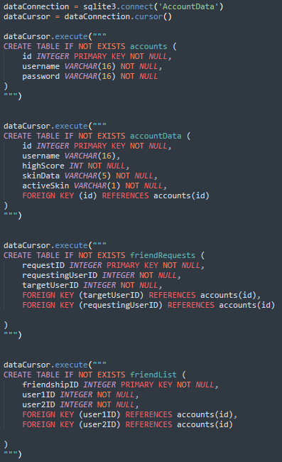

Testing

Test 1 a
The first thing I needed to implement and code was the textBoxClass, which is then used to take the inputs of the username and password in both the signup screen and login screen.
My first test with this textbox was whether or not the ‘Active’ Boolean would be toggled to True/False at the correct times. This meant that when I clicked onto the signup screen, neither the username or password textbox would be toggled on and “not active” would be being printed. Then, if I clicked on it, I expected the textbox to expand slightly and print “active”. Then, when I clicked off the textbox, the printing should stop and print “not active”
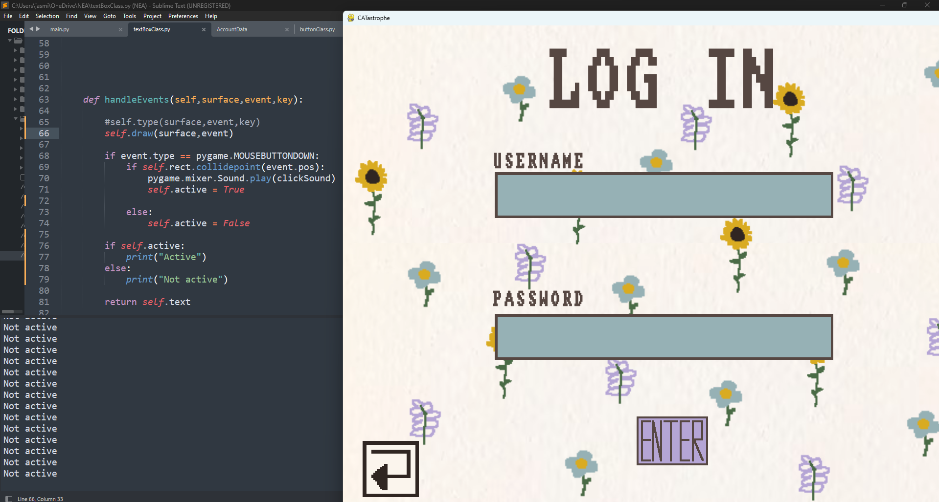
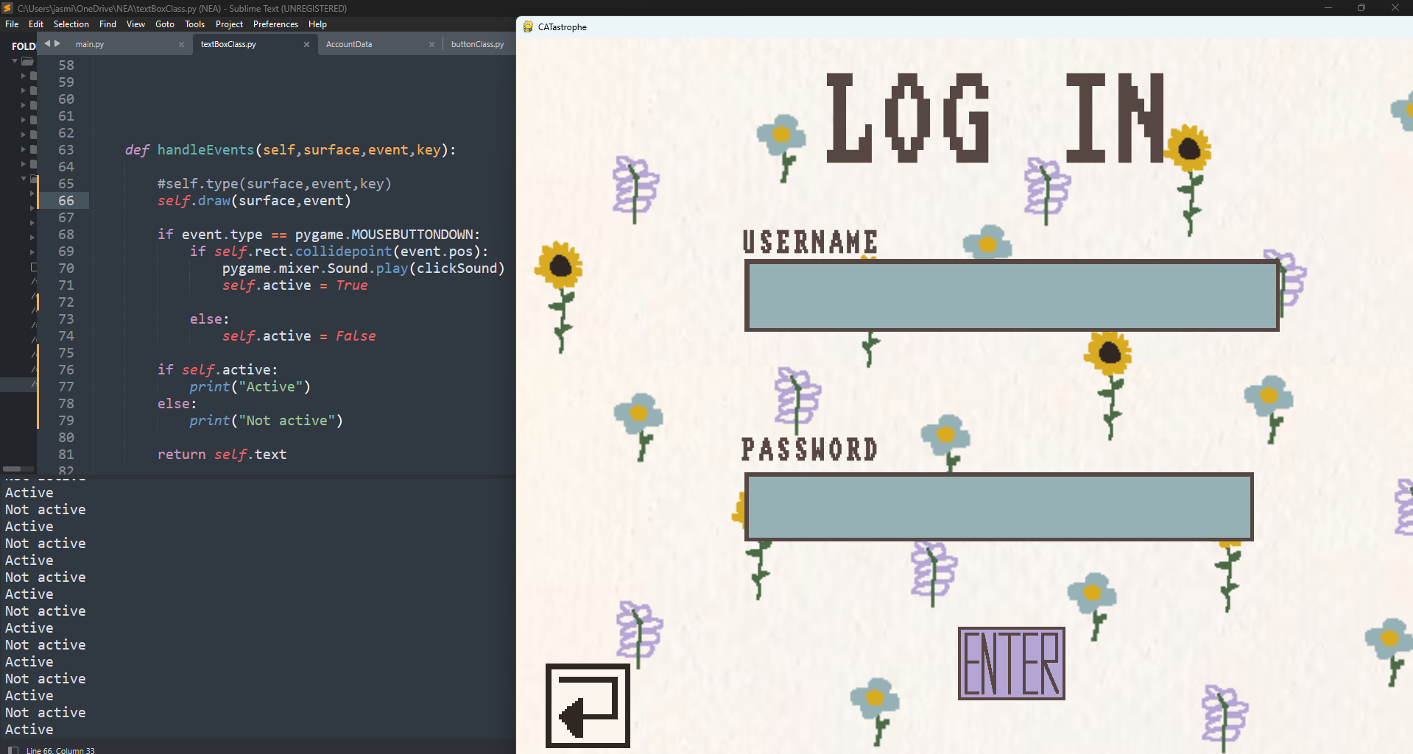
The result of this run was a success, because there were two textboxes present on screen, where both printed “not active” when I Initially clicked onto the Log In screen. Then, when I clicked on one of the textboxes, only one of them changed to “active” whereas the other one remained not active. This was what I expected, and when I clicked off the textbox it reverted to both printing “not active”

Test 1 b

My next test was for the actual typing and displaying of the text in the textbox. I decided to constantly print what self.text is every loop whilst I typed “Test”. This is because I needed to see whether or not the code would display the correct text on screen, aswell as actually updating correctly when I typed.
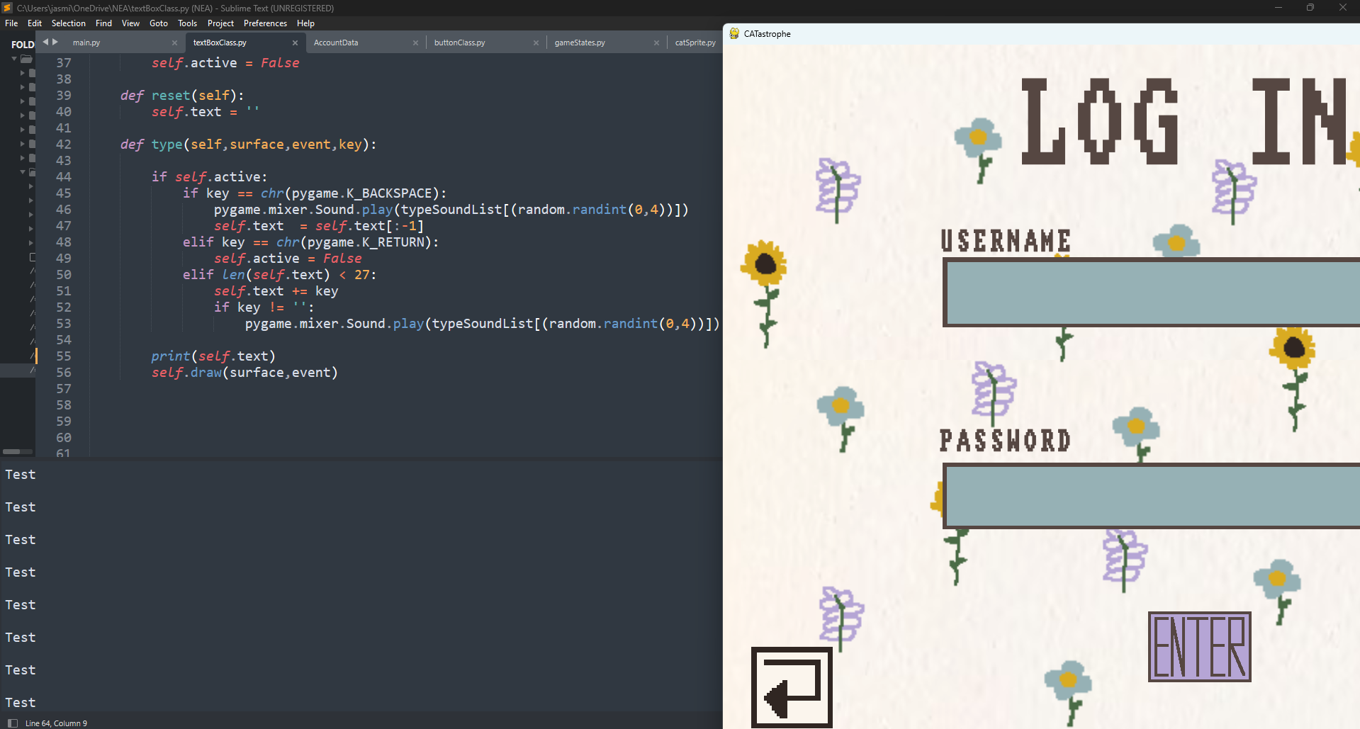

After doing this, I found that when I would type something, self.text would update and print out whatever I was typing, however would not display on screen. Although this part didn’t work, the sounds being played also worked fine This suggested the issue was with the text_surface variable, and that I wasn’t updating it correctly. I added a section of code which updated text_surface every loop instead of only when the user was finished typing, which resulted in the text being displayed correctly in the textbox.
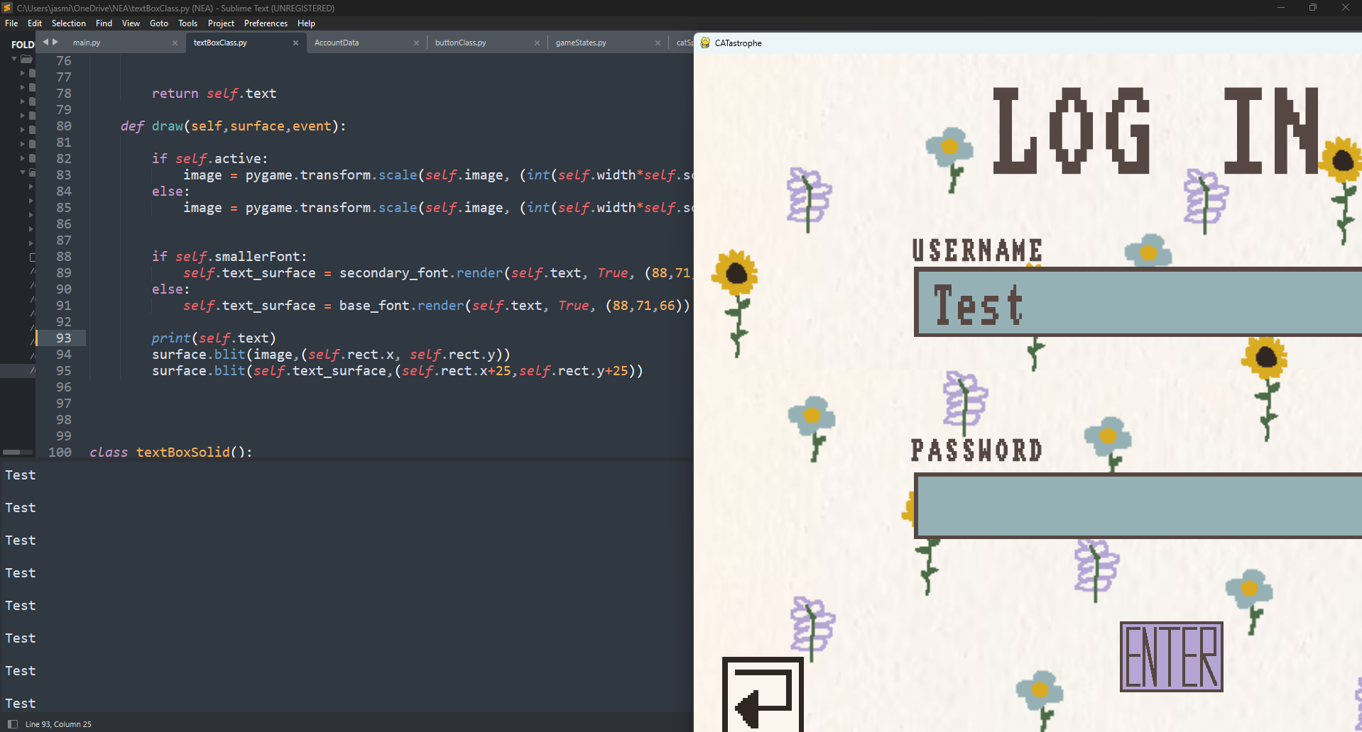

Test 1 c
My next test consisted of wanting both username and password to be returned correctly to the main program. This meant typing in a test username and test password into the textboxes and pressing the enter button. Then, in the main program, I would have the text of these textboxes being continuously assigned to a variable which would then only be printed if the enter button was pressed.
The test username I used was Username1 and the password was Password1
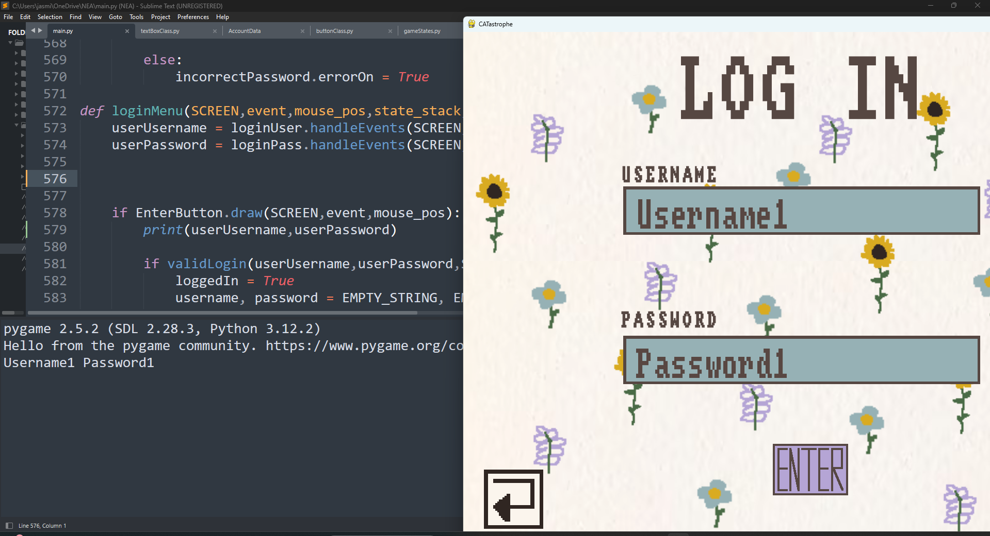
This worked as expected, with both the username and password being returned successfully to the main program. This meant I could then proceed with writing the validation needed for both the login and signup screen.
Test 2 a
The next thing I wanted to code was creating the database which included the accounts and accountData table. I translated the pseudocode in the previous section into python in order to create the tables and put it before anything else (with where the constants are) in my program. Then, I ran my program which created a ‘Accounts.db’ file in the same folder as the python program. With the table now created, I could work towards inserting records with the username and password the user enters in the signup screen.
The insertion itself was relatively simple, and just consisted of taking the inputs when the user presses ‘Enter’ and creating a new record. I then printed every item in the accounts table in order to see whether or not the primary key, username, and password were inserted correctly.
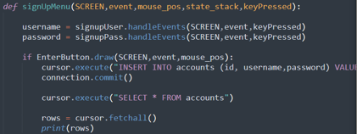
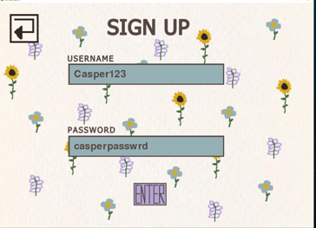
This correctly printed all the records in accounts, including the one I had just typed.
Test 2 b
My next step was to code and test the validation of signing up, which includes hashing a password which has at least 1 number or letter, and is over 7 characters.
The first validation I wanted to implement was whether or not an account with that username already exists. I wrote the subroutine validInput which returned a number based on which error occurred. An errorNum of ‘1’ meant that an account with that username exists
An errorNum of ‘2’ meant the username was too short, and an errorNum of ‘3’ meant that there was an issue with the password.
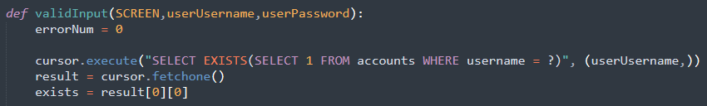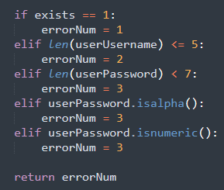
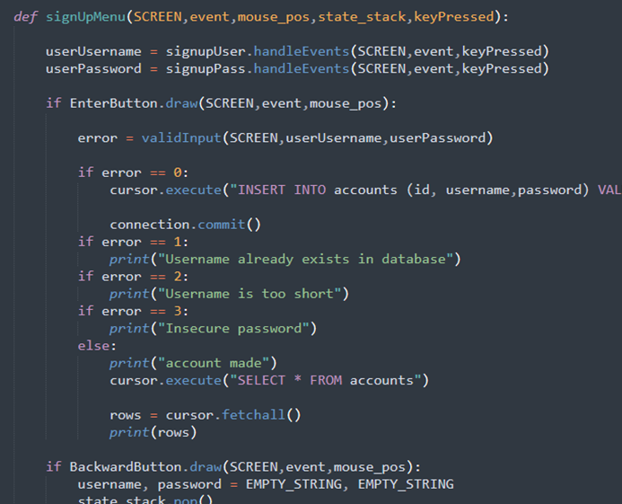

The errorNum would then be returned to the signUpMenu subroutine and print off an appropriate error message depending on the value in errorNum. This could be so I knew whether or not the correct error was happening for a piece of test data.
Database will already have one account which is Jasmine123 : Password123
 | Data input | Expected | Actual
1 | Rosa123 : Password349234 | Account made | Account made
2 | jASmine123 : Pass43289 | Username already exists | Account made
3 | Casp : Otto1234 | Username too short | Username is too short,
4 | Casper123 : Otto | Insecure password | Insecure password
5 | Casper9548 : Ottooooooo | Insecure password | Insecure password
6 | Rosa123 : Password4232 | Username already exists | Username already exists
7 | Jude123 : 123123123123 | Insecure password | Insecure password

I realised for test three I had to change the ‘error == (num)’ to ELIF instead of IF statements as it printed ‘account made’ for every test despite not actually creating the account.
Create test screenshots

Evaluation

Bibliography

[1] | C. W. Russ, “Youtube,” 15 01 2023. [Online]. Available: https://www.youtube.com/watch?v=y9VG3Pztok8&t=2s.
[2] | W. o. Python, “Youtube,” 15 09 2021. [Online]. Available: https://www.youtube.com/watch?v=5-WGGYLT8E8.

